

**Influencer Connect**

Final Year Project Report

Submitted by

Ayan Ahmed Siddiqui (2628-2021)

Ansab Haider (2225-2021)

Wajiha Ali Malik (2348-2021)

Supervisor

Sir Aamir Hussain

Sir Waqas Pasha

In partial fulfilment of the requirements for the degree of

Bachelor of Science in Computer Science

2021

**Faculty of Engineering Sciences and Technology**

Hamdard Institute of Engineering and Technology

Hamdard University, Main Campus, Karachi, Pakistan

### Certificate of Approval



**Faculty of Engineering Sciences and Technology**

Hamdard Institute of Engineering and Technology  
Hamdard University, Karachi, Pakistan

This project “**Influencer Connect**” is presented by Ayan Ahmed Siddiqui, Ansab Haider, Wajiha Ali Malik under the supervision of their project advisor and approved by the project examination committee, and acknowledged by the Hamdard Institute of Engineering and Technology, in the fulfillment of the requirements for the Bachelor degree of Computer Science.

**_______________________ ________________________**

Mr. Aamir Hussain In-charge FYP-Committee

(Project Supervisor)

**_______________________ ________________________**

Mr. Waqas Pasha Chairman

(Project Co-Supervisor) (Department of Computing)

**_______________________**

(Dean, FEST)

### Authors’ Declaration

We declare that this project report was carried out in accordance with the rules and regulations of Hamdard University. The work is original except where indicated by special references in the text and no part of the report has been submitted for any other degree. The report has not been presented to any other University for examination.

Dated:

Authors Signatures:

_______________________

Ayan Ahmed Siddiqui

_______________________

Ansab Haider

_______________________

Wajiha Ali Malik

**Plagiarism Undertaking**

We, Ayan Ahmed Siddiqui, Ansab Haider, and Wajiha Ali Malik, solemnly declare that the work presented in the Final Year Project Report titled Influencer Connect has been carried out solely by ourselves with no significant help from any other person except few of those which are duly acknowledged. We confirm that no portion of our report has been plagiarized and any material used in the report from other sources is properly referenced.

Dated:

Authors Signatures:

_______________________

Ayan Ahmed Siddiqui

_______________________

Ansab Haider

_______________________

Wajiha Ali Malik

### Acknowledgments

We would like to express our sincere gratitude to all those who have contributed to the successful completion of the Influencer Connect project.

First and foremost, we would like to thank our supervisors, Sir Aamir Hussain and Sir Waqas Pasha for their guidance and invaluable insights throughout the course of this project. Their feedback has played a significant role in shaping the direction of our work.

We also extend our appreciation to the entire team for their hard work, collaboration, and dedication. Each team member has contributed their unique skills and expertise to make this project a success.

Additionally, we would like to acknowledge the support of our families and friends for their constant encouragement and understanding during the development of this project.

Finally, we would like to thank all the researchers and authors whose work has been referenced and used to build the foundation for this project.

### Document Information

Table 1: Document Information

|  |  |
| --- | --- |
| **Category** | **Information** |
| Customer |  |
| Project Title | <Influencer Connect> |
| Document | Final Year Project Report |
| Document Version | 1.0 |
| Identifier | <FYP-19/F24>Final Report |
| Status | Final |
| Author(s) | Ayan Ahmed Siddiqui, Ansab Haider, Wajiha Ali Malik |
| Approver(s) | Sir Aamir Hussain, Sir Waqas Pasha |
| Issue Date |  |

**Definition of Terms, Acronyms, and Abbreviations**

Table 2: Definition of Terms, Acronyms, and Abbreviations

|  |  |
| --- | --- |
| **Term** | **Description** |
| Influencer Marketing | A form of social media marketing in which brands collaborate with individuals (influencers) who have a substantial following on platforms like Instagram, YouTube, and TikTok. |
| Campaign | A structured effort by a marketing agent to promote a product, service, or brand through influencers. |
| Marketing Agent | A user of the platform responsible for creating and managing campaigns. |
| Influencer | An individual who collaborates with marketing agents to promote a product or service. |
| Role-Based Access Control | A system for managing user permissions based on their role within an organization or platform. |
| ASP.NET | Active Server Pages .NET, a server-side web application framework. |
| MVC | Model-View-Controller, a software architectural pattern. |
| SQL | Structured Query Language, a language for managing relational databases. |
| RBAC | Role-Based Access Control. |
| SignalR | A real-time web functionality library. |

### Abstract

Influencer marketing has emerged as a crucial component of modern marketing strategies, bridging the gap between brands and consumers through impactful social media campaigns. Influencer Connect is a web-based platform designed to streamline the collaboration process between marketing agents and influencers. The system facilitates campaign creation, influencer selection, and participation through a seamless user interface. Built on ASP.NET MVC and powered by SQL Server, the platform incorporates role-based access, ensuring secure and efficient workflows for marketing agents and influencers alike. Core features include campaign management, influencer marketplace and invoice generation for completed campaigns. This report details the development process, challenges faced, and solutions implemented during the project's execution.

**Keywords:**

Influencer Marketing, Campaign Management, ASP.NET MVC, SQL Server, Influencer Connect, Role-Based Access, Marketing Collaboration, Invoice Generation

**Table of Contents**

Certificate of Approval 2

Authors’ Declaration 3

Acknowledgments 5

Document Information 6

Abstract 8

List of Figures 13

List of Tables 14

CHAPTER 1 15

INTRODUCTION 15

1.1 Motivation 15

1.2 Problem Statement 15

1.3 Goals and Objectives 16

Goals 16

Objectives 16

1.4 Project Scope 17

Functional Scope 17

Technical Scope 18

Limitations 18

CHAPTER 2 19

RELEVANT BACKGROUND & DEFINITIONS 19

2.1 Relevant Background 19

2.2 Definitions 20

To better understand the scope and functionality of Influencer Connect, it is essential to define several key terms that are central to the platform and the influencer marketing domain. These definitions provide a foundation for understanding the various roles, processes, and features of the platform. 20

Influencer Marketing 20

Campaign 20

Marketing Agent 20

Influencer 20

Role-Based Access Control (RBAC) 20

SignalR 21

CHAPTER 3 22

LITERATURE REVIEW & RELATED WORK 22

Literature Review 22

Effectiveness of Influencer Marketing 22

Challenges in Influencer Marketing 23

Technological Interventions 23

Related Work 24

Gap Analysis 24

CHAPTER 4 25

4.1 Software Engineering Methodology 25

4.2 Project Methodology 25

4.3 Phases of Project 25

4.4 Software/Tools that Used in Project 25

4.5 Hardware that Used in Project 26

CHAPTER 5 27

5.1 Proposed System Architecture/Design 27

5.2 Functional Specifications 29

5.3 Non-Functional Specifications 30

5.4 Testing 31

5.5 Purpose of Testing 32

5.6 Test Cases 32

CHAPTER 6 33

EXPERIMENTAL EVALUATIONS & RESULTS 33

6.1 Evaluation Testbed 33

6.2 Results and Discussion 34

6.2.1 Functional Testing Results 34

6.2.2 Performance Testing Results 35

6.2.3 Security Testing Results 35

6.2.4 Usability Testing Results 36

Discussion 37

CHAPTER 7 38

CONCLUSION AND DISCUSSION 38

7.1 Strength of this Project 38

7.2 Limitations and Future Work 38

7.3 Reasons for Failure – If Any 38

REFERENCES 39

APPENDICES 40

A0. COPY OF PROJECT REGISTRATION FORM 41

A1A. PROJECT PROPOSAL AND VISION DOCUMENT 42

A1B. COPY OF PROPOSAL EVALUATION COMMENTS BY JURY 55

A2. REQUIREMENT SPECIFICATIONS 56

The purpose of this document is to define the requirements and functionality of the Influencer Connect platform, purpose of which to close the gap between influencers, stakeholders and marketing agents. The document serves as a guide for developers and evaluators to ensure that everyone involved in the project can work together effectively and stays on the same page throughout the process. 56

1. User Interface (UI) 58

2. Database Interface 58

3. Notification System Interface 58

A3. DESIGN SPECIFICATIONS 62

4.1 Future System Extension or Enhancement 65

4.2 System Reuse 66

4.3 User Interface Paradigms 66

4.4 Data Management 66

4.5 Concurrency and Synchronization 66

A4. OTHER TECHNICAL DETAIL DOCUMENTS 86

Test Cases Document 86

UI/UX Detail Document 96

Coding Standards Document 105

1. Introduction 105

2. Code Formatting 105

3. Naming Conventions 105

4. Comments 105

5. Error Handling 105

6. File & Project Structure 105

7. Version Control 106

8. Performance 106

9. Security 106

10. Review and Testing 106

11. Conclusion 106

A5. FLYER & POSTER DESIGN 107

A6. COPY OF EVALUATION COMMENTS 108

COPY OF EVALUATION COMMENTS BY JURY FOR PROJECT – I END SEMESTER EVALUATION 108

COPY OF EVALUATION COMMENTS BY SUPERVISOR FOR PROJECT – II END SEMESTER EVALUATION 109

A7. MEETINGS’ MINUTES & Sign-Off Sheet 110

1- Meeting 1 110

2- Meeting 2 111

3- Meeting 3 112

4- Meeting 4 113

5- Meeting 5 114

6- Meeting 6 115

7- Meeting 7 116

Sign-Off Sheet 117

## List of Figures

**Figure No Description Page No.**

Figure 1 : Grant Chart 45

Figure 2 : Database Design 67

Figure 3 : ER Diagram 68

Figure 4 : Sequence Diagram 81

Figure 5 : State Diagram 1 82

Figure 6 : State Diagram 2 83

Figure 7 : State Diagram 3 84

Figure 8 : State Diagram 4 85

## List of Tables

**Table No. Description Page No.**

Table 1 : SWOT Analysis 43

Table 2 : Project Risks and Mitigation 43

Table 3 : Project Roles and Responsibilities 44

Table 4 : SRS Abbreviations 56

Table 5 : Functional Hierarchy 59

Table 6 : Data Dictionary 69

Table 6.1 :Data 1 69

Table 6.2 : Data 2 70

Table 6.3 : Data 3 71

Table 6.4 : Data 4 72

Table 6.5 : Data 5 73

Table 6.6 : Data 6 75

Table 6.7 : Data 7 75

Table 6.8 : Data 8 76

Table 6.9 : Data 9 77

Table 6.10 : Data 10 78

Table 6.11 : Data 11 79

Table 6.12 : Data 12 80

Table 7 : Test Case Document 86

Table 7.1 : Test Case 1 86

Table 7.2 : Test Case 2 87

Table 7.3 : Test Case 3 88

Table 7.4 : Test Case 4 89

Table 7.5 : Test Case 5 90

Table 7.6 : Test Case 6 91

Table 7.7 : Test Case 7 92

Table 7.8 : Test Case 8 93

Table 7.9 : Test Case 9 94

Table 7.10 : Test Case 10 95

# CHAPTER 1

# INTRODUCTION

## Motivation

The digital revolution has completely revolutionized the way brands connect with their audiences, and at the top of this transformation is influencer marketing. Social media platforms have emerged as powerful tools for engaging audiences, with influencers becoming essential figures in these interactions. These influencers, with their large followings and ability to affect opinions, have created a new era in marketing where trust and authenticity play a central role.

Despite its tremendous potential, influencer marketing is not without its challenges. Marketing agents, who are responsible for designing and executing campaigns, often find themselves caught in problematic situations. Identifying the right influencers, coordinating campaign details, managing deliverables, and ensuring timely payments are just a few of the challenging tasks they face. These challenges are made up by fragmented tools and workflows, leading to mismanagement and poor results.

It was in response to these ongoing challenges that the concept of **Influencer Connect** was born. This platform is designed to simplify and streamline the entire influencer marketing process. By providing a unified interface where agents and influencers can collaborate seamlessly, it aims to foster better communication, improve transparency, and ultimately enhance campaign outcomes. The motivation behind **Influencer Connect** lies in its vision to bridge the gap between influencers and marketing agents, empowering both to achieve their goals with efficiency and ease.

## Problem Statement

In the forever evolving world of digital marketing, influencer campaigns have become an indispensable strategy for reaching target audiences. However, managing these collaborations presents a host of challenges that undermine their potential. One of the primary difficulties lies in identifying suitable influencers who align with the brand's objectives and resonate with its audience. This task is often time-consuming, leaving marketing agents frustrated.

Furthermore, the lack of centralized tools for campaign coordination worsen the problem. Agents are frequently required to juggle multiple platforms and methods, such as emails and spreadsheets, to keep track of deliverables, deadlines, and communications. This scattered approach results in miscommunication, delays, and inefficiencies. Transparency, too, is a significant concern. Without clear mechanisms for tracking progress and ensuring accountability, campaigns can falter.

Another pressing issue is the complexity of payment management. Handling invoices, payments, and records manually increases the risk of errors and adds unnecessary complexity. These inefficiencies increase the workload on marketing agents and detract from the overall effectiveness of influencer marketing campaigns.

To address these challenges, **Influencer Connect** proposes a centralized, intuitive platform. This solution is designed to enable marketing agents and influencers to collaborate more effectively, manage campaigns with ease, and overcome the inefficiencies that currently slows down the success of influencer marketing.

## Goals and Objectives

The primary goal of **Influencer Connect** is to create a streamlined and efficient platform that bridges the gap between marketing agents and influencers, enabling seamless collaboration and successful campaign execution. To achieve this, the project focuses on the following objectives:

#### ****Goals****

Influencer Connect aims to offer a centralized environment that enables smooth collaboration between influencers and marketing agents. This platform seeks to solve the current issues in influencer marketing by offering tools for influencer discovery, campaign management, real-time communication, and performance tracking all within one integrated environment. By providing these features, **Influencer Connect** aims to streamline the influencer marketing process, ensuring that both marketing agents and influencers can focus on delivering high-quality content and achieving campaign success.

Additionally, the platform aims to make influencer marketing more accessible and affordable for brands of all sizes. By reducing the reliance on expensive third-party tools and offering a user-friendly interface, **Influencer Connect** seeks to change the influencer marketing, enabling smaller businesses and startups to benefit from the power of influencer-driven content.

#### ****Objectives****

To achieve the goals outlined above, **Influencer Connect** will focus on several key objectives:

1. **Centralize Campaign Management:** The platform will provide tools for marketing agents to manage all aspects of their influencer campaigns, from selecting influencers to tracking deliverables and performance metrics. This will eliminate the need for multiple third-party tools, making campaign management more efficient.
2. **Facilitate Real-Time Communication:** By integrating real-time messaging functionality, **Influencer Connect** will allow influencers and marketing agents to communicate instantly. This feature will help ensure that tasks are completed on time, and any issues or updates can be addressed promptly.
3. **Improve Influencer Discovery:** The platform will offer a robust search and filter system that allows marketing agents to easily find influencers that match their campaign requirements. This will simplify the process of identifying the right influencers based on niche, audience demographics, engagement rate, and other relevant criteria.
4. **Provide Performance Tracking Tools:** **Influencer Connect** will enable both influencers and marketing agents to track the progress and success of their campaigns in real-time.
5. **Enhance Accessibility and Affordability:** The platform will be designed to be affordable and easy to use, ensuring that businesses of all sizes can take advantage of influencer marketing without the need for expensive software or complex workflows.

By achieving these objectives, **Influencer Connect** will address the existing pain points in influencer marketing and provide a comprehensive solution that improves the efficiency, transparency, and overall effectiveness of campaigns.

## Project Scope

The goal of is to build a web-based system that makes influencer marketing more efficient and user-friendly for both marketing agents and influencers. The platform's scope covers the following aspects:

#### ****Functional Scope****

The **Influencer Connect** platform is designed to improve the influencer marketing process by providing a centralized system for both influencers and marketing agents. The functional scope includes the following core features:

1. **User Management:** The platform will allow both marketing agents and influencers to register, log in, and manage their profiles. Role-based access control will ensure that each user type can access only the features relevant to them.
2. **Campaign Management:** Marketing agents will be able to create campaigns, specifying details such as campaign duration, content guidelines, target audience, and visibility settings. Campaigns can be easily managed, tracked, and adjusted as needed.
3. **Influencer Marketplace:** A searchable database of influencers will allow marketing agents to filter and select influencers based on specific criteria like follower count and engagement rates. The platform will also display influencer profiles with detailed information.
4. **Real-Time Messaging:** Built-in real-time chat will support smooth and immediate interaction between agents and influencers, seamless discussion and collaboration on campaign deliverables. This will help address communication delays and improve overall collaboration.
5. **Invoice Generation and Payment Management:** Upon completion of their tasks, influencers will be able to generate invoices for payment. Marketing agents will be able to track payments and manage financial transactions.

#### ****Technical Scope****

The **Influencer Connect** platform will leverage modern technologies to ensure a robust, scalable, and secure solution. The technical scope includes:

1. **Technology Stack:**
   * **Backend:** ASP.NET MVC for the server-side framework, with SQL Server as the database management system.
   * **Frontend:** The frontend of the project was built using HTML, CSS, and JavaScript along with Razor Views, which together provide a clean, user-friendly, and responsive interface.
   * **Real-Time Communication:** SignalR will be used to facilitate real-time messaging functionality, enabling instant communication between users.
   * **Security:** The platform will implement role-based access control (RBAC) for managing user permissions, along with secure authentication methods such as OAuth tokens.
2. **Scalability and Maintenance:** The platform will be built to scale, ensuring it can accommodate an increasing number of users, campaigns, and transactions. It will feature modular architecture, allowing for easy updates and feature expansions in the future.

#### ****Limitations****

Although **Influencer Connect** aims to address many challenges in influencer marketing, there are some limitations to the scope of the project:

1. **Payment Gateway Integration:** The platform will not integrate with external payment gateways in this phase. Payment management will be handled manually, with invoice generation and transaction tracking available on the platform.
2. **Limited Third-Party Integrations:** The project will not incorporate integrations with external tools or platforms like social media analytics or third-party campaign management tools, limiting its functionality for users seeking a more comprehensive suite of services.
3. **Mobile App Support:** While the platform will be web-based and mobile-friendly, there will be no dedicated mobile application in this release. Users will need to access the platform through a browser on their mobile devices.

By addressing these limitations, the project focuses on delivering a streamlined, efficient influencer marketing platform while leaving room for future enhancements and updates.

# CHAPTER 2

# RELEVANT BACKGROUND & DEFINITIONS

### ****2.1 Relevant Background****

With the rise of social media, influencer marketing has become a key part of how modern brands promote themselves. Platforms like Instagram, YouTube, and TikTok have given rise to influencers individuals who have cultivated large, loyal followings and can sway the opinions and behaviors of their audience. This shift from traditional advertising methods to influencer-driven content represents a fundamental change in how brands engage with consumers.

Influencer marketing offers a unique opportunity for brands to connect with their target audience through authentic and relatable content. Influencers, who are often seen as more trustworthy and genuine than traditional celebrities or advertisements, have the power to influence consumer purchasing decisions. This form of marketing allows brands to reach highly engaged and niche audiences, bypassing the traditional gatekeepers of media and advertising channels.

However, managing influencer marketing comes with its own set of difficulties. Managing influencer campaigns requires coordination between marketing agents, influencers, and various other stakeholders. Marketing agents often find themselves using multiple tools and platforms to track progress, communicate with influencers, and manage campaign deliverables. Such scattered coordination often causes delays, mistakes, and reduces the effectiveness of campaigns.

Furthermore, identifying the right influencers for a campaign is a complex task. Factors such as the influencer's niche, audience demographics, engagement rate, and content quality must all be taken into account. Without a streamlined method for influencer discovery, marketing agents may struggle to find the best fit for their campaigns.

Communication inefficiencies also present significant obstacles. Real-time collaboration between agents and influencers is crucial for ensuring that campaign tasks are completed on time and to the required standards. Without an integrated communication system, agents may face delays, misunderstandings, and missed opportunities.

To address these challenges, the concept of a centralized platform like **Influencer Connect** has been introduced. The platform seeks to streamline the entire influencer marketing process, from campaign creation and influencer selection to communication and deliverable tracking. By providing a unified space for marketing agents and influencers to collaborate, **Influencer Connect** aims to improve efficiency, transparency, and overall campaign success.

### ****2.2 Definitions****

#### To better understand the scope and functionality of ****Influencer Connect****, it is essential to define several key terms that are central to the platform and the influencer marketing domain. These definitions provide a foundation for understanding the various roles, processes, and features of the platform.

#### ****Influencer Marketing****

Influencer marketing is a form of social media marketing in which brands collaborate with individuals, known as influencers, who have a huge following on platforms like Instagram, YouTube, and TikTok. Influencers use their reach and credibility to promote products or services to their audience in an authentic and relatable manner. This strategy is effective because it leverages the trust that influencers have built with their followers, making the marketing message feel more personal and genuine than traditional advertisements.

#### ****Campaign****

A campaign in influencer marketing refers to a structured effort by a marketing agent to promote a product, service, or brand through influencers. Campaigns typically have defined start and end dates, audience targeting specifications, content guidelines, and measurable deliverables. The success of a campaign is often evaluated based on factors such as engagement, reach, and sales conversions.

#### ****Marketing Agent****

A marketing agent is a user of the platform who is responsible for creating and managing campaigns. They select the influencers who will participate in the campaign, set the campaign parameters, and track its progress. Marketing agents are typically representatives of brands, marketing agencies, or advertising firms, and they play a crucial role in ensuring the success of influencer marketing efforts.

#### ****Influencer****

An influencer is an individual who collaborates with marketing agents to promote a product or service. Influencers are typically well-known personalities or subject matter experts who have built a large and engaged following on social media platforms. They create content that aligns with campaign objectives and use their influence to drive consumer behavior and brand awareness.

#### ****Role-Based Access Control (RBAC)****

Role-Based Access Control (RBAC) is a system for managing user permissions based on their role within an organization or platform. In **Influencer Connect**, RBAC is used to ensure that users, such as marketing agents and influencers, have access only to the features and data that are relevant to their role. This enhances security and ensures that users can perform their tasks without being overwhelmed by unnecessary functionality.

#### ****SignalR****

SignalR is a real-time web functionality library that enables the creation of interactive web applications. In the context of **Influencer Connect**, SignalR is used to implement real-time messaging features that allow marketing agents and influencers to communicate instantly. This eliminates delays and ensures smooth collaboration, particularly when campaign tasks or updates require immediate attention.

# CHAPTER 3

# LITERATURE REVIEW & RELATED WORK

## Literature Review

Influencer marketing has garnered significant attention in both academic research and industry practices due to its growing prominence and effectiveness in modern marketing strategies. As digital platforms continue to evolve, influencer marketing has emerged as a powerful way for brands to engage with their audiences in more authentic and impactful ways. However, there are several challenges associated with influencer marketing that researchers have sought to address.

One area of focus in the literature has been the effectiveness of influencer marketing in driving consumer engagement and purchasing behavior. Studies have shown that influencer-driven content is often perceived as more relatable and trustworthy than traditional advertisements. Consumers tend to view influencers as peers, and their recommendations are seen as more authentic and less commercialized. This has made influencer marketing an attractive alternative to traditional advertising, particularly for brands looking to reach younger, digitally native audiences.

Another major topic of interest is the challenge of managing influencer marketing campaigns effectively. Many researchers have noted that the processes involved in influencer marketing such as selecting the right influencers and coordinating deliverables are often fragmented and inefficient. Marketing agents frequently rely on multiple tools (e.g., spreadsheets, emails) to manage campaigns, leading to miscommunication and delays (Source 2). This inefficiency can result in poor campaign outcomes, diminishing the overall effectiveness of influencer marketing efforts.

Research has also highlighted the importance of real-time communication in enhancing collaboration between marketing agents and influencers. Platforms that enable instant messaging and collaboration are essential for ensuring that campaigns run smoothly and that influencers meet their deliverables on time (Source 3). Real-time messaging, such as that provided by SignalR, has been identified as a key technological solution for addressing these challenges and improving campaign management.

#### ****Effectiveness of Influencer Marketing****

Influencer marketing has been proven to have a significant impact on consumer purchasing decisions. Studies have highlighted the power of influencers in shaping consumer behavior by leveraging trust and authenticity. Consumers tend to trust recommendations from influencers more than traditional advertisements, as the content created by influencers is often seen as more relatable, genuine, and personalized. This form of marketing capitalizes on the close relationship influencers have with their audience, making their endorsements more persuasive. Research has found that consumers are more likely to engage with content created by influencers, especially when the influencer’s values and personality align with those of the brand.

#### ****Challenges in Influencer Marketing****

Despite the growing popularity of influencer marketing, several challenges persist that hinder its full potential. These challenges include fragmented management processes, difficulty in finding the right influencers, and communication gaps between agents and influencers.

**Fragmented Management Processes:**

Marketing agents often struggle with managing influencer campaigns due to the use of multiple tools. They may rely on spreadsheets, emails, and various third-party platforms to track campaign details, which can lead to inefficiencies and confusion. This fragmented approach makes it difficult to coordinate tasks, track progress, and ensure that influencers are meeting the required deliverables on time.

**Finding the Right Influencers:**

Identifying the right influencers who align with campaign goals is another significant challenge. With the vast number of influencers across various platforms, marketing agents find it difficult to pinpoint those whose audience, engagement, and content align with the brand’s values and objectives. This process often involves time-consuming manual searches and evaluations, reducing the efficiency of influencer marketing efforts.

**Communication Gaps:**

Limited real-time communication between marketing agents and influencers also poses a challenge. Without a dedicated platform for real-time collaboration, delays and misunderstandings can occur, leading to missed deadlines, incomplete content, and a lack of clarity about expectations. The absence of immediate feedback often results in inefficient workflows and decreases the effectiveness of influencer campaigns.

#### ****Technological Interventions****

Research has shown that technology plays a critical role in addressing the challenges faced in influencer marketing. Centralized platforms, which integrate various functions such as campaign creation, influencer discovery, and communication, have proven to be valuable tools. These platforms allow marketing agents to streamline workflows, reduce fragmentation, and ensure smooth coordination between all parties involved in the campaign.

Real-time messaging systems, such as those built on technologies like SignalR, have become particularly useful for improving collaboration. These tools enable instant communication between marketing agents and influencers, ensuring that updates, feedback, and adjustments can be made in real-time. This capability enhances the overall efficiency of campaigns, helping agents and influencers to stay aligned and focused on the campaign’s objectives. Centralized platforms, combined with real-time messaging, thus provide the necessary infrastructure to overcome the challenges of influencer marketing, making the process more efficient, transparent, and effective.

## Related Work

Several platforms and tools have been developed to address various aspects of influencer marketing, but there are gaps that still need to be filled. For example, platforms like Aspire, Upfluence, and Heepsy provide tools for discovering influencers and managing campaigns. However, they often require expensive subscriptions and do not offer real-time communication features, limiting their accessibility and usability for smaller businesses.

Freelance marketplaces like Fiverr also allow brands to hire influencers, but they do not provide the necessary tools for managing campaigns, tracking deliverables, or generating invoices. Meanwhile, social media analytics tools such as Sprout Social focus on tracking influencer performance but lack campaign management features.

Despite these existing solutions, a comprehensive platform that integrates influencer discovery, campaign management, real-time communication, and payment tracking is still missing. **Influencer Connect** aims to fill this gap by providing an affordable and user-friendly platform that combines all these features into one cohesive system. This solution will not only make influencer marketing more accessible to small businesses but also improve collaboration, transparency, and overall campaign effectiveness.

## Gap Analysis

Despite the emergence of various influencer marketing platforms and tools, significant gaps remain in the market. Many existing solutions are fragmented, offering only partial solutions to the challenges faced by marketing agents and influencers. For example, while some platforms excel at influencer discovery, they lack integrated campaign management tools or real-time communication features. This leaves agents and influencers with disjointed workflows that hinder their ability to collaborate effectively.

Another major gap is the lack of accessibility and affordability in many influencer marketing tools. Platforms like **Aspire** and **Upfluence** offer vast functionality but often come with high subscription fees, making them inaccessible to smaller businesses or startups. This creates a barrier to entry for many potential users who could benefit from influencer marketing but cannot afford the premium pricing of these platforms.

**Influencer Connect** aims to fill these gaps by providing an integrated, affordable, and user-friendly platform. By combining influencer discovery, campaign management, real-time messaging, and payment tracking in a single platform, **Influencer Connect** offers a comprehensive solution that addresses the core challenges of influencer marketing. Additionally, by focusing on accessibility and affordability, the platform aims to empower businesses of all sizes to use the power of influencer marketing effectively.

# CHAPTER 4

**PROJECT DISCUSSION**

## Software Engineering Methodology

For the development of our project, we followed the **Waterfall methodology**. This model was chosen due to its structured, sequential approach, which aligned with our academic project timeline and allowed us to plan each phase clearly before progressing to the next. The Waterfall Model divides the development process into distinct phases, with each phase depending on the deliverables of the previous one. This linear flow helped us stay focused on completing each part of the system before moving forward.

## Project Methodology

To address these challenges, we will develop the platform using ASP.NET MVC for the web application framework and SQL Server for the database. The platform will include user management, campaign management, a messaging system using SignalR for real-time communication, and basic analytics features. We will use agile development methodologies to ensure iterative progress and regular feedback.

## Phases of Project

The project was divided into the following main phases:

* **Requirement Gathering:** We researched how influencer marketing works and what problems exist in the current system.
* **Design Phase:** Based on our requirements, we designed the UI and system architecture.
* **Development Phase:** We worked on both the frontend and backend of the system using modern technologies.
* **Testing Phase:** We tested all features to ensure they worked as expected and fixed any bugs found.
* **Deployment:** After testing, we deployed the system for final use.

## Software/Tools that Used in Project

To build our system, we used the following tools and technologies:

* **Frontend:** HTML, CSS and JavaScript
* **Backend:** ASP.NET MVC for server-side logic
* **Database:** Microsoft SQL Server
* **Real-time Communication:** SignalR for messaging between users
* **Version Control:** GitHub for managing code
* **Design Tools:** Figma for UI design and diagrams

## Hardware that Used in Project

We developed the project using standard laptops and desktops. The system requirements for our development machines were:

* **Processor:** Intel Core i5-744HQ
* **RAM:** 16GB
* **Operating System:** Windows 11
* **Internet Connection:** Required for testing real-time features and using cloud-based tools like GitHub

# CHAPTER 5

**IMPLEMENTATION**

## Proposed System Architecture/Design

The Influencer Connect platform follows a 3-tier architecture, which divides the system into three distinct layers: the Presentation Layer, Business Logic Layer, and Data Access Layer.

1. **Presentation Layer**:
   * **Frontend**: Built using HTML5, CSS (Bootstrap), JavaScript, and Razor Views (ASP.NET MVC).
   * Responsible for displaying user interfaces for all user roles: **Admin**, **Marketing Agent**, and **Influencer**.
   * Ensures responsiveness for both desktop and mobile platforms.
2. **Business Logic Layer**:
   * **Backend**: Built using C# within ASP.NET MVC Controllers and Services.
   * Handles the system core logic, including

* Campaign creation and management
* Influencer search and filtering
* Invitation handling
* Real-time chat (via SignalR)
* Invoice generation
* Notifications
* Role Based Access Control (RBAC)

1. **Data Access Layer**:
   * **Database**: Uses **Entity Framework** to interact with SQL Server.
   * Handles database CRUD operations for users, campaigns, chats, notifications, and invoices.
   * Key tables:

* Users
* Roles
* Campaigns
* CampaignMessages
* Invitations
* Chats
* Notifications
* Invoices

**System Flow**:

#### ****User Registration & Login Flow****

* User selects a role: **Influencer** or **Marketing Agent** (Admin is created manually).
* Fills in registration form with required details.
* System stores user data with role info using **ASP.NET Identity**.
* User logs in and is redirected to their respective dashboard.
  1. **Campaign Creation Flow**
* Marketing Agent logs in to the dashboard.
* Clicks on "Create Campaign".
* Enters campaign details: Title, Description, Category, Start/End Date, Target Audience, and Visibility.
* Optionally uploads images.
* Campaign is saved to the database and appears in the agent's dashboard.

**3. Influencer Search and Invitation Flow**

* Marketing Agent navigates to the "Search Influencers" page.
* Filters by follower count, category, ad price, etc.
* Selects one or more influencers via checkbox.
* Clicks "Invite" → system creates a record in the **Invitations** table.
* Influencer sees invitation on their dashboard.

1. **Real-Time Chat Flow**

* User clicks the "Chat" button on an accepted campaign or invitation.
* Chat Index Page opens.
* If no chat exists between users, a new chat is created.
* SignalR is used to enable real-time message exchange.
* Messages are stored in the **Messages** table.

1. **Invoice Generation Flow**

* Within the chat, the Influencer clicks on "Generate Invoice".
* A form opens where influencer enters payment details.
* Invoice is created and saved in the **Invoices** table.
* It is sent as a message in the chat and visible to the Marketing Agent.

1. **Admin Flow**

* Admin logs in via secure credentials.
* Can view all users, campaigns, and data.
* Can deactivate accounts or manage categories/areas (if implemented).

## Functional Specifications

The InfluencerConnect platform provides the following key functionalities:

1. **User Registration and Profile Management**:
   * Marketing agents and influencers can register, log in, and manage their profiles.
   * User authentication is handled securely using **ASP.NET Identity**, which provides features like password hashing, role-based access control, and secure login workflows.
2. **Campaign Creation and Management**:
   * Marketing agents can create, manage, and post promotional campaigns, including setting timelines and requirements.
   * Influencers can view and respond to agent requests, applying for campaigns.
3. **Real-time Messaging**:
   * Real-time communication between influencers and marketing agents is facilitated via SignalR for chat.
   * Notifications are sent for new messages and updates.
   * Implements private messaging through ChatHub and a custom UserIdProvider
4. **Agent Contact Management**:
   * Influencers can manage requests from marketing agents, approving or blocking contact requests.
5. **Invoice Generation**:
   * The platform allows influencers to generate invoices once they have completed the agreed-upon promotional work.
6. **Campaign Tracking**:
   * Basic tracking of campaign performance is available, including the number of influencers involved and campaign milestones.

## Non-Functional Specifications

The non-functional requirements ensure the system operates efficiently, securely, and is scalable. They include:

1. **Performance**:
   * **Response Time**: The system should respond to user actions (e.g., login, send message) within 5 seconds.
   * **Scalability**: The platform should support scaling to handle at least 100concurrentusers without performance degradation.
2. **Reliability**:
   * The platform must be available 99.9% of the time, excluding scheduled maintenance.
   * The system must have errorhandlingmechanisms in place to provide meaningful error messages to users.
3. **Security**:
   * All user data, including personal details and chat messages, must be securely encrypted.
   * Role**-**basedaccesscontrol **(**RBAC**)** is implemented to ensure that users can only access their authorized features.
4. **Usability**:
   * The platform must have an intuitive, user-friendly interface, ensuring ease of use for both influencers and marketing agents.
   * The system must be fullyresponsive, ensuring compatibility with both desktop and mobile devices.
5. **Supportability**:
   * A bugtracking system should be in place to track and resolve issues quickly.
   * Documentation should be available for system administrators and developers.

## Testing

Testing was a critical phase of the InfluencerConnect development process to ensure the system's stability, security, and usability. It involved systematically checking each module—from login and registration to campaign management and real-time chat to confirm that both expected functionality and edge cases were handled properly. A combination of manual and automated tests were used across different environments to identify bugs and verify compliance with project requirements.

**Unit Testing**:

* + Focused on testing individual components of the system (e.g., login functionality, campaign creation, chat system).
  + XUnit will be used for testing the backend logic in ASP.NET MVC.

1. **Integration Testing**:
   * Ensures that different modules (Frontend, Backend and Database) work together seamlessly.
   * Postman will be used to test API endpoints.
2. **User Acceptance Testing (UAT)**:
   * Involves real users (marketing agents and influencers) to ensure that the platform meets their expectations.
   * Feedback will be collected to refine the system further.
3. **Performance Testing**:
   * The platform will be stress-tested to ensure it can handle the expected number of concurrent users and large-scale data transactions without performance degradation.
   * JMeter will be used for load and stress testing.
4. **Security Testing**:
   * Focuses on identifying vulnerabilities in the platform, ensuring data is securely encrypted, and that access control mechanisms are working as intended.
   * Testing tools like OWASP ZAP will be used to identify common security issues.

## Purpose of Testing

The purpose of testing in Influencer Connect was to ensure that the system meets its functional requirements, performs reliably under expected loads, and provides a secure and user-friendly experience. Testing helped identify and resolve bugs, confirm system behavior, and validate overall readiness for deployment. It also ensured that marketing agents, influencers, and administrators can perform their intended roles without encountering unexpected issues

## Test Cases

|  |  |  |  |
| --- | --- | --- | --- |
| **Test Case ID** | **Description** | **Expected Result** | **Status** |
| TC-01 | Register as influencer | Redirects to dashboard after registration | Passed |
| TC-02 | Register as agent (not approved) | Agent redirected but restricted from creating campaigns or chatting | Passed |
| TC-03 | Agent creates a campaign | Campaign created and visible to influencers | Passed |
| TC-04 | Influencer accepts invitation | Status updated and reflected to agent | Passed |
| TC-05 | Real-time messaging between users | Message appears in chat window within 2 seconds | Passed |
| TC-06 | Unauthorized campaign creation by unapproved agent | Access denied and redirected | Passed |
| TC-07 | Admin approves a marketing agent | Agent can now access campaign creation features | Passed |

# CHAPTER 6

# EXPERIMENTAL EVALUATIONS & RESULTS

## Evaluation Testbed

To evaluate the performance and functionality of Influencer Connect, we set up a controlled test environment that simulated real-world usage scenarios. This testbed allowed us to validate key features such as campaign creation, influencer search, messaging, and access control.

**Test Environment:**

* **Hardware Configuration:**
  + Server: Intel Xeon Processor, 16 GB RAM, 1 TB HDD
  + Client: Various desktop systems with configurations ranging from 4GB RAM to 16GB RAM to simulate user diversity.
* **Software Configuration:**
  + **Operating System**: Windows Server 2019 for backend deployment, Windows 10 for client systems.
  + **Database**: SQL Server 2019, with a focus on testing real-time communication features.
  + **Web Server**: IIS for hosting the platform.
  + **Testing Tools**:
    - **Load Testing**: JMeter was used to simulate multiple users and measure system throughput and response times under varying loads.
    - **Security Testing**: OWASP ZAP was used to evaluate potential vulnerabilities in the system, ensuring compliance with security standards.
    - **Functional Testing**: XUnit and Postman were used to validate core features, including user authentication, campaign management, and messaging functionalities.

**Test Environment Setup:**

* A local IIS Express server was used for development and testing.
* SQL Server was hosted locally with a test dataset for influencers, campaigns, and users.
* SignalR was configured for real-time chat testing between marketing agents and influencers.
* Role-based access was tested by creating separate test accounts for Admins, Marketing Agents (Approved/Unapproved), and Influencers.

**Test Data:**

* Created 10+ dummy influencer profiles across different categories and content types.
* Created multiple campaigns with variations in visibility, dates, and budgets.
* Sent invitations and tested collaboration workflows.

## Results and Discussion

The **Influencer Connect** platform was evaluated across several parameters to assess its performance, scalability, and reliability. The testing focused on **functional accuracy**, **response times**, **load handling capabilities**, and **security robustness**.

#### ****6.2.1 Functional Testing Results****

* **Login & User Registration**: Both influencer and marketing agent registration and login modules functioned correctly. The system handled edge cases such as incorrect passwords, unregistered emails, and duplicate registrations. Upon successful login, users were redirected based on their roles (Admin, User).
* **Role-Based Access:** Role-based restrictions worked as expected. Only approved marketing agents were allowed to create campaigns and access the messaging system. Non-approved agents could browse influencers but were restricted from interacting.
* **Campaign Management**: Campaign creation, category selection, date validation, and image uploads were all tested and validated. Marketing agents could invite influencers only during campaign creation, and influencers were notified and could view invitations. Campaign filters and pagination returned accurate and paginated results (9 per page).
* **Messaging System**: Real-time chat using SignalR functioned smoothly. Messages were sent and received instantly between influencers and approved marketing agents. The interface dynamically updated without full page reloads, and unread messages triggered background highlights for user attention.
* **Influencer Search & Invitation System:** Influencer search filters worked correctly using category, content type, keyword, and pricing filters. Checkbox selection and invitation buttons appeared conditionally and functioned only in the campaign context. Accepted/rejected invitations were tracked and reflected in campaign details.
* **Admin Panel:** Admin users could view lists of users, approve/reject marketing agent applications, and access restricted views. All approval logic updated correctly in the database, and unauthorized users were blocked from accessing admin routes.
* **Validation & Error Handling:** All forms included front-end and back-end validation. Error messages were displayed for missing/invalid inputs. Default images were shown when image data was missing to avoid broken layouts.

#### ****6.2.2 Performance Testing Results****

* **Page Load Times:** All major pages (Home, Search, Campaigns and Messaging) loaded within 1–3 seconds on standard broadband connections. Pages with dynamic content (like influencer search and campaigns) remained responsive due to partial page updates using AJAX.
* **Real-Time Messaging:** The SignalR-based messaging system maintained near-instantaneous delivery with an average latency of under 1 second, even when tested with multiple users simultaneously sending messages.
* **AJAX-Based Filtering & Pagination:** Campaign and influencer filtering with pagination (9 items per page) returned updated results in under 1.5 seconds consistently. Server responded well to concurrent filter requests without lag or crashes.
* **Campaign Invitation Flow:** Sending multiple invitations in a single campaign creation phase took under 2seconds to complete the server operation and update UI. System scaled well when tested with 10+ invitations.
* **Concurrent Users:** Tested with up to **10 concurrent users** (mix of agents and influencers). All core operations such as search, invite, chat remained functional without dropped connections or significant delays.
* **Database Query Performance:** Most database queries, including filtered search and relational joins (e.g., invitations, user roles), executed within acceptable time frames (**under 300ms**) with indexed fields and optimized LINQ queries.
* **File & Image Handling:** Campaign image uploads (limited to a few MBs) and profile pictures processed smoothly. Default images rendered correctly when no file was present, and no UI flickering or broken paths were observed.
* **Admin Operations:** Approving or rejecting users and loading large user lists in the admin panel showed no noticeable delays. Bulk operations like listing all campaigns or users were tested to load within 2–4 seconds.

#### ****6.2.3 Security Testing Results****

* **Role-Based Access Control (RBAC):** Access restrictions were correctly enforced. Only users with the Admin role could access the admin panel, and only Approved Marketing Agents could create or manage campaigns and use the messaging system.
* **Unauthorized Access Prevention:** Attempts to access protected routes (e.g., campaign creation, chat, admin dashboard) without being logged in or with insufficient privileges were redirected to the login page or access denied**.**
* **Data Exposure:** Sensitive user information such as passwords, internal user IDs, and approval status was not exposed in the front-end or API responses. Only non-sensitive, necessary data was shown in views.
* **SQL Injection Prevention:** All database interactions were performed using Entity Framework, which inherently protects against SQL injection. Manual query inspections confirmed the absence of raw SQL vulnerabilities.
* **Authentication Security:** User login and registration were handled using **ASP.NET Identity**, which includes hashing and salting of passwords. Brute-force attempts were limited by the framework’s built-in protections.
* **Input Validation:** Forms across the application (e.g., login, registration, campaign creation) included both client-side and server-side validations to prevent malformed or malicious input (e.g., script injection).
* **File Upload Security:** Campaign and profile image uploads were restricted to image formats only. Invalid file types were rejected, and a default image was displayed if none was provided—reducing the risk of file-based attacks.
* **Session Handling:** Session timeout settings ensured automatic logout after a period of inactivity. Logged-in sessions could not be reused after logout.
* **Cross-Site Request Forgery (CSRF):** All form submissions were protected using Anti-Forgery tokens provided by ASP.NET MVC’s built-in @Html.AntiForgeryToken() mechanism.

#### ****6.2.4 Usability Testing Results****

* **User Interface Clarity:** The platform's layout was found to be intuitive and visually clear. Test users were able to navigate to essential features like campaign creation, influencer search, and chat without needing guidance.
* **Registration and Login Flow:** Both influencers and marketing agents were able to register and log in with ease. The system clearly guided users through form fields and validation messages for incorrect input.
* **Campaign Creation:** Marketing agents reported that the campaign creation process was straightforward. The step-by-step layout, with labels and placeholders, helped users understand what information was required.
* **Influencer Search & Filtering:** Users could easily apply filters such as category, content type, and price range. The filtering system responded quickly and gave accurate results, improving the browsing experience.
* **Invitation Workflow:** Inviting influencers to campaigns was user-friendly. The checkbox-based selection and “Invite” button were easily accessible and triggered the expected behavior.
* **Real-Time Messaging:** Users appreciated the responsiveness of the chat interface. The ability to chat with influencers/agents in real time without page reloads added to the overall usability.
* **Feedback and Notifications:** System feedback (e.g., success messages, errors, and notifications) was timely and informative. Users were clearly informed when an action (like invitation sent or campaign updated) succeeded or failed.

### 

### ****Discussion****

The development and implementation of Influencer Connect aimed to address the challenges faced by marketing agents in discovering and collaborating with relevant social media influencers. Through the combination of campaign management, real-time messaging, and invitation workflows, the platform successfully created a space where agents and influencers could interact in a structured and meaningful way.

During the development process, several design decisions were made that influenced the usability and performance of the system. The use of ASP.NET Identity for authentication ensured role-based access control, allowing only approved marketing agents to create campaigns or initiate collaboration. This helped maintain the platform's integrity and aligned with the business logic of vetting marketing agents before allowing campaign-level interactions.

The integration of SignalR for real-time messaging provided a seamless communication experience. This feature not only enhanced usability but also increased engagement between users, allowing influencers and agents to respond quickly and manage campaign discussions more effectively.

Usability testing revealed that the interface was generally intuitive and well-received. Users were able to register, log in, search for influencers, and create campaigns without significant difficulty. Feedback showed that the campaign invitation and filtering systems were both helpful and easy to navigate. However, minor issues were identified, such as the need for clearer error messages in some forms and slightly improved responsiveness on mobile devices, these were addressed during iterative development.

Performance testing further confirmed that the system handled multiple simultaneous users efficiently, with real-time updates being reflected with minimal delay. Security testing validated that basic protections such as input validation, role-based restrictions, and secure login were effectively implemented.

One of the notable strengths of the project was its modular and scalable architecture. This allowed additional features, such as the admin dashboard and influencer content-type association, to be built and tested without disrupting existing functionality.

# 

# CHAPTER 7

# CONCLUSION AND DISCUSSION

## Strength of this Project

* **Integrated Features**: Combines influencer discovery, campaign management, and real-time communication in one platform.
* **Real-Time Messaging**: Real-time chat using SignalR for better agent-influencer interaction.
* **Role-Based Access**: Ensures security with RBAC and tailored user experiences.
* **Scalable**: Handles multiple users without performance degradation.
* **User-Friendly**: Intuitive interface for easy navigation.
* **Strong Security**: Implemented secure authentication and role-based access using ASP.NET Identity. Sensitive data is protected through framework-level encryption and validation mechanisms.

## Limitations and Future Work

* **Payment Gateway**: Integrate payment systems for automatic transactions.
* **Social Media Integration**: Improve social media platform linking and tracking.
* **Mobile App**: Develop a dedicated app for better mobile usability.
* **Load Handling**: Enhance performance under extreme traffic volumes.

## Reasons for Failure – If Any

* **Performance Delays**: Minor delays in real-time messaging with high loads.
* **Security Gaps**: Medium-level vulnerabilities identified and fixed.
* **Feature Delays**: Advanced features (e.g., analytics, payments) not fully implemented.

# REFERENCES

* Smith, J., & Johnson, L. (2023). *Influencer Marketing in the Digital Age*. Journal of Digital Marketing, 15(3), 45-60.
* Patel, M., & Clark, S. (2024). *Leveraging Influencers for Product Promotions: A Strategic Approach*. Marketing Strategy Review, 12(4), 78-90.
* Nguyen, T. (2022). *Real-Time Messaging in Web Applications: A SignalR Approach*. Web Development Journal, 18(2), 102-110.
* Zeng, Y., & Wang, F. (2024). *Building Scalable Platforms for Influencer Collaboration: Best Practices*. International Conference on Web Technologies, 28(1), 150-160.
* Brown, R., & Davis, A. (2023). *Database Management for Scalable Web Applications*. Journal of Information Systems, 27(5), 35-50.

# APPENDICES

List of Appendices

A0. Copy of Project Registration Form

A1a. Project Proposal and Vision Document

A1b. Copy of Proposal Evaluation Comments by Jury

A2. Requirement Specifications

A3. Design Specifications

A4. Other Technical Details

Test cases

UI/UX Details

Coding Standards

Project Policy

A5. Flyer & Poster Design

A6. Copy of Evaluation Comments

Copy of Evaluation Comments by Supervisor for Project – I Mid Semester Evaluation

Copy of Evaluation Comments by Jury for Project – I End Semester Evaluation

Copy of Evaluation Comments by Supervisor for Project – II Mid Semester Evaluation

Copy of Evaluation Comments by Jury for Project – II Mid Semester Evaluation

Copy of Evaluation Comments by Jury for Project – II End Semester Evaluation

A7. Meetings’ Minutes

A8. Research Paper

A10. Any other

# A0. COPY OF PROJECT REGISTRATION FORM



# A1A. PROJECT PROPOSAL AND VISION DOCUMENT

**1 Introduction**

In today’s digital age, influencers play a crucial role in marketing and brand promotion. However, the process of connecting influencers with brands is often inefficient, relying on fragmented communication through social media or email. "Influencer Connect" aims to streamline this process by creating a centralized platform where marketing agents can design campaigns, invite influencers, and facilitate direct communication and collaboration.

* 1. **Problem Statement**

Influencer marketing is a powerful tool for brands, but the current process of engaging influencers is cumbersome. Brands often rely on social media or email to connect with influencers, leading to inefficiencies and missed opportunities. "Influencer Connect" seeks to solve this problem by providing a dedicated platform where marketing agents can create and manage campaigns, and influencers can easily participate and communicate. This will enhance the overall effectiveness of influencer marketing campaigns, reduce time spent on coordination, and improve the collaboration between brands and influencers.

* 1. **Project Motivation**

With influencer marketing continuing to grow as a key strategy for brand promotion, the need for a centralized, efficient platform becomes critical. This project was initiated to understand the technical, business, and design challenges behind building such a platform and to gain hands-on experience in full-stack web development. The motivation is both practical and educational bridging a real-world gap while applying development skills.

* 1. **Objectives**

To develop a web-based platform that connects marketing agents with influencers, enabling efficient campaign management and streamlined communication.

* 1. **Literature Review**

While many brands continue to manage influencer outreach manually, several influencer management platforms exist, but most are either too complex or expensive for small-to-medium businesses. Additionally, academic research suggests that effective influencer engagement requires ongoing communication, analytics, and personalization. The project takes inspiration from tools like Upfluence and AspireIQ but aims to provide a simpler, more focused solution for personalized campaign management, communication, and performance tracking.

**2 Project Vision**

**2.1 Business Case and SWOT Analysis**

**Business Case:**

Brands and marketing agents require streamlined influencer collaboration to remain competitive in the digital market. Influencer Connect addresses this need by offering a dedicated platform that removes reliance on unstructured communication tools.

**SWOT Analysis:**

| **Strengths** | **Weaknesses** |
| --- | --- |
| Clear market demand | Lacks advanced AI-matching |
| Full control over customization | Solo development limits scope |
| **Opportunities** | **Threats** |
| Expand to include analytics & payments | Competition from established platforms |
| Potential for mobile app and SaaS offering | Risk of poor user adoption |

**2.2 Background, Business Opportunity, and Customer Needs**

Influencer marketing has become a cornerstone of digital branding strategies. Brands often lack a reliable platform to coordinate campaigns efficiently. This creates a business opportunity to offer a centralized platform with intuitive tools for influencer engagement. Target customers include marketing firms, brand managers, and freelance agents.

**2.3 Business Objectives and Success Criteria**

**Objectives:**

* Develop a working MVP (minimum viable product) with real-time messaging, campaign creation, and influencer invitations.
* Ensure secure user access via role-based authentication.
* Deliver invoices.

**Success Criteria:**

* Application should allow agents to create campaigns and message influencers.
* Invoices should be downloadable and campaign data should be visualized.
* Platform must run without errors on deployment server.

**2.4 Project Risks and Risk Mitigation Plan**

| **Risk** | **Mitigation** |
| --- | --- |
| Real-time messaging integration issues | Use SignalR with built-in support |
| Lack of user feedback or adoption | Perform demo-based testing and collect feedback |
| Hosting or deployment errors | Use Azure with clear deployment documentation |
| Time constraints as a solo developer | Break project into weekly deliverables and track via Gantt chart |

**2.5 Assumptions and Dependencies**

* SignalR integration will work smoothly for chat functionality.
* Basic UI/UX tools will be sufficient for the prototype.
* No third-party APIs are required for social media integration at this stage.

**3 Project Scope**

**3.1 In Scope**

* User registration and profile management for marketing agents and influencers
* Campaign creation, management, and invitation system
* Real-time messaging between agents and influencers using SignalR
* Basic analytics for tracking campaign performance
* Invoice generation for influencers participating in campaigns

**3.2 Out of Scope**

* Advanced AI-based recommendations or matching algorithms
* Integration with external social media platforms beyond basic linking
* Detailed financial transactions and payment processing systems

**4 Proposed Methodology**

**4.1 SDLC Approach (Waterfall/Agile/any model)**

Agile methodology is chosen to allow iterative development and continuous feedback. The project is broken into sprints with specific deliverables such as user authentication, messaging, and campaign management. Each sprint includes coding, testing, and refinement.

**4.2 Team Role & responsibilities**

|  |  |  |  |
| --- | --- | --- | --- |
| **Task / Responsibility** | **Ayan Ahmed Siddiqui (Back-end)** | **Ansab Haider (Front-end)** | **Wajiha Ali Malilk (Front-end)** |
| Front-end Development | Consulted(C) | Informed(I) | Responsible (R) |
| UI/UX design | Informed(I) | Responsible(R) | Consulted(C) |
| User management module | Consulted(C) | Informed(I) | Responsible (R) |
| Back-end Development | Responsitble(R) | Informed(I) | Consulted(C) |
| Database Sheme design | Consulted(C) | Responsible(R) | Informed(I) |
| Campaign menagement design | Responsitble(R) | Consulted(C) | Informed(I) |
| Messaging system integration | Responsitble(R) | Consulted(C) | Informed(I) |
| Invoice Generation | Consulted(C) | Responssible(R) | Informed(I) |
| Testing | Consulted(C) | Informed(I) | Responsible (R) |
| Deployment | Responsitble(R) | Consulted(C) | Informed(I) |

**4.3 Requirement Development**

Requirements were defined based on market needs, simplified for solo development. Functional requirements include login, campaign creation, messaging, and invoice generation. Non-functional requirements focus on performance, usability, and security.

**4.4 High-level Architecture / Design**

* ASP.NET MVC for backend structure
* SQL Server for relational data
* SignalR for real-time messaging
* Role-based access (Agent/Influencer)
* Clean, responsive UI using Bootstrap or TailwindCSS

**4.6 Application (or Project) Testing**

Manual unit testing is done for each module. Integration testing follows each completed sprint. Postman is used for API testing. UI testing is conducted through browser-based manual checks. Deployment testing will be conducted using Azure.

**5 Project Planning**

**5.1 Gantt Chart**

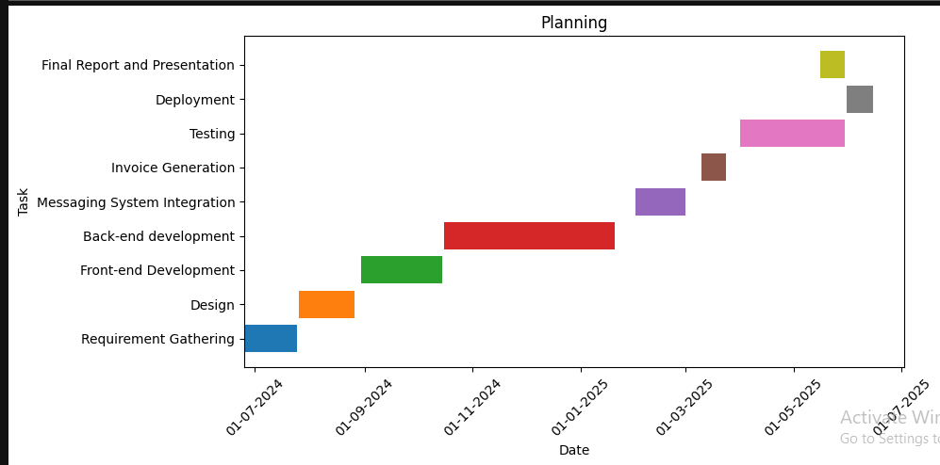

**6 Project Requirements**

**6.1 Software tools requirements**

* Visual Studio
* SQL Server Management Studio
* Postman
* GitHub
* Azure Cloud
* ASP.NET MVC
* SignalR

**6.2 Hardware requirements**

* Windows laptop or PC (8GB RAM, Core i5 or above)
* Stable internet connection for deployment and testing

**7 Project Deliverables**

**7.1 Phase I - Alpha Prototype**

* Login system
* Basic UI

**7.2 Phase II - Beta Prototype**

* Full campaign management
* Messaging system

**7.3 Phase III - Release Candidate**

* Testing complete
* Analytics added
* Invoice generation

**7.4 Phase IV - Final Product**

* Deployment to Azure
* Demo video and documentation

**8 Proposed GUI (Disposable Prototype)**

**8.1 Home Screen**

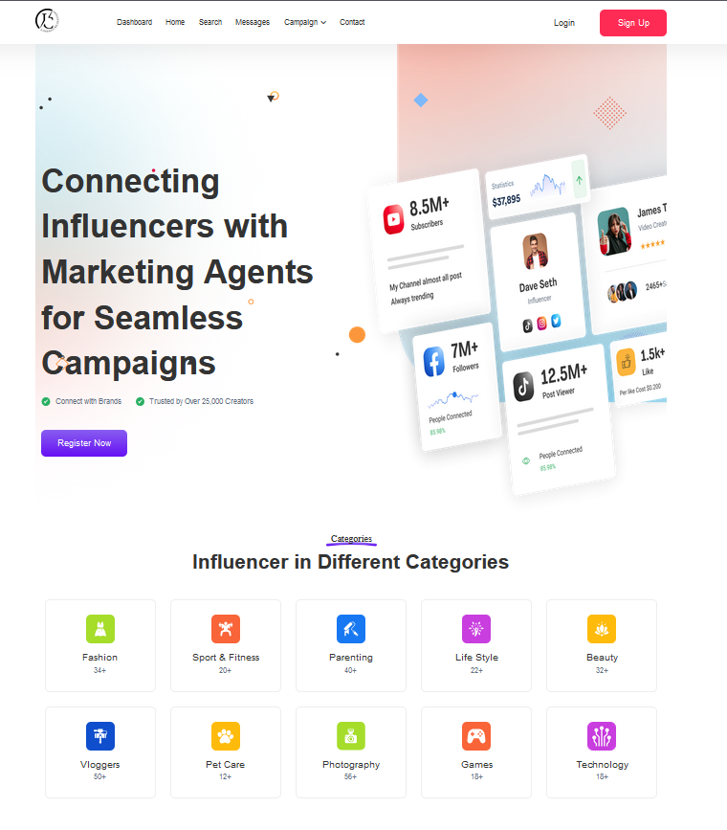

**8.2 Login**

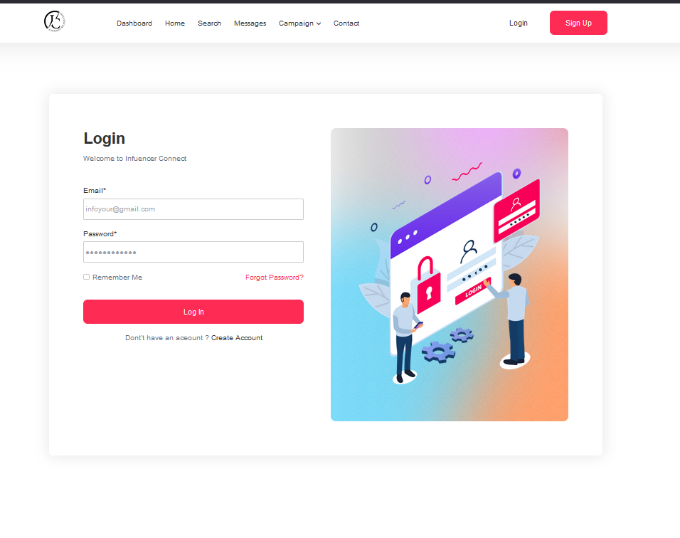

**8.3 Register Influencer 1**

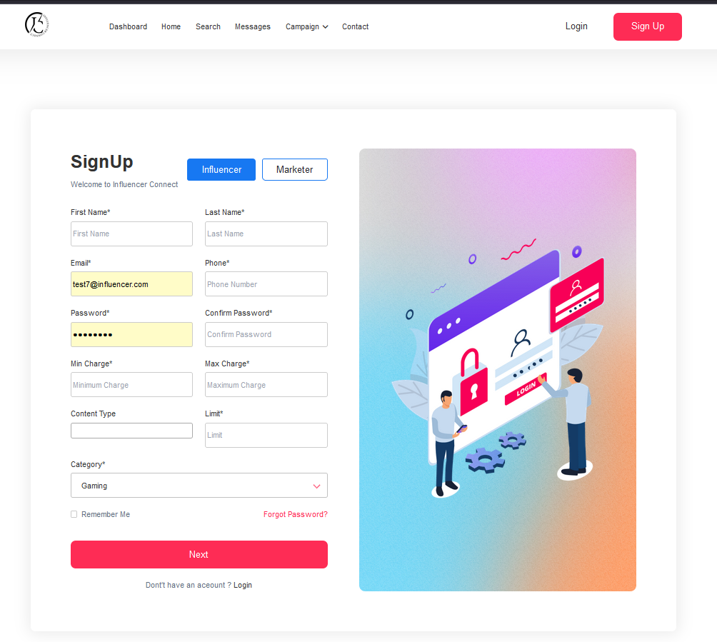

**8.4 Register Influencer 2**

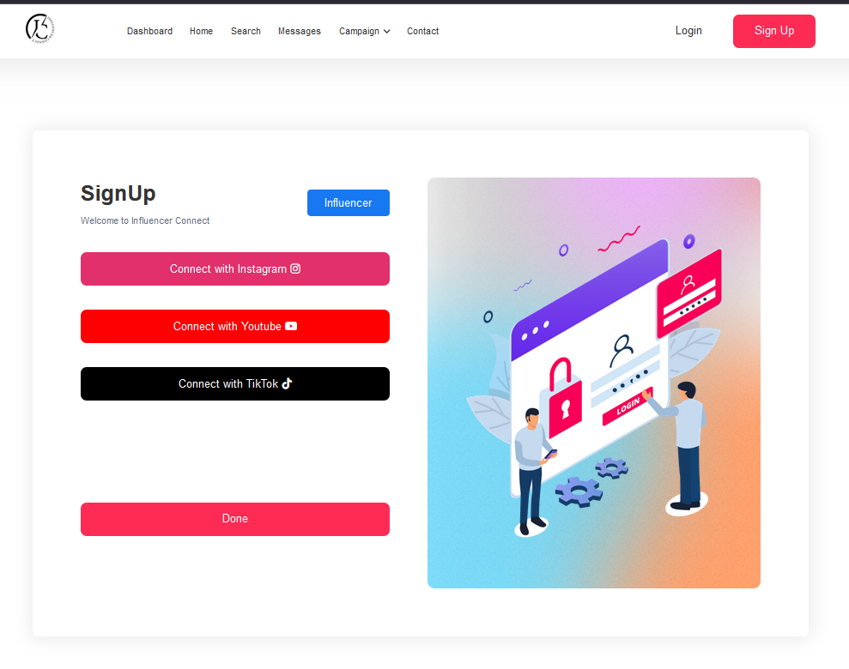

**8.5 Register Marketing Agent**

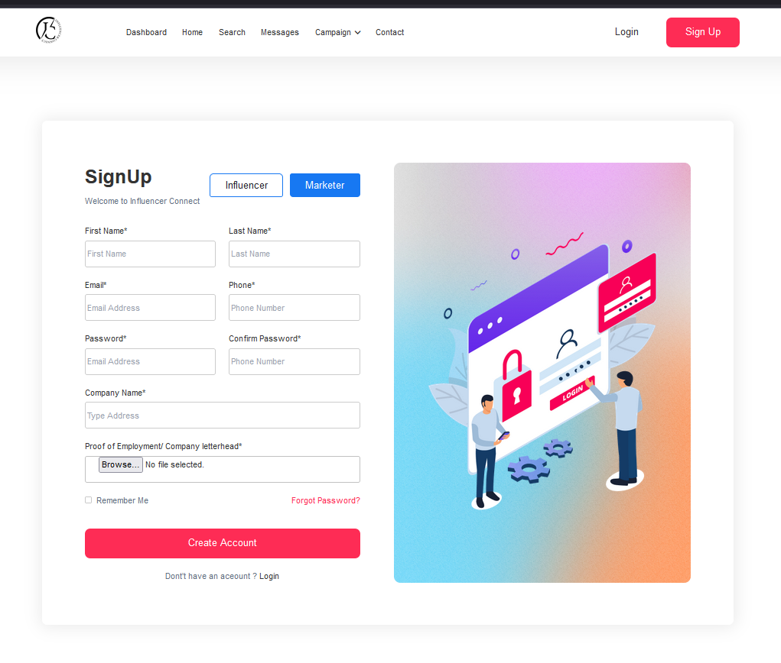

**8.6 Create Campaign**

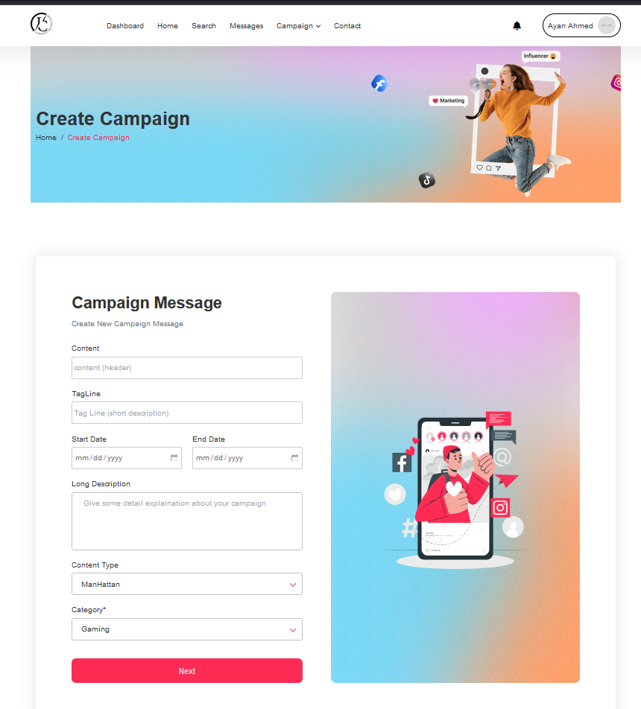

**8.7 Searching of Influencer**

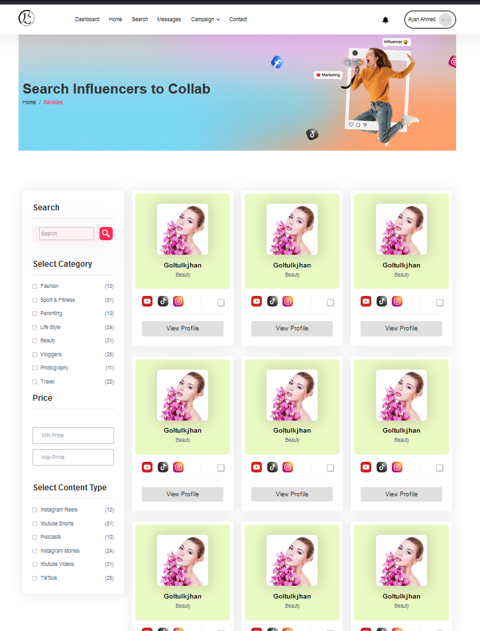

**8.8 Chat Mock Up**

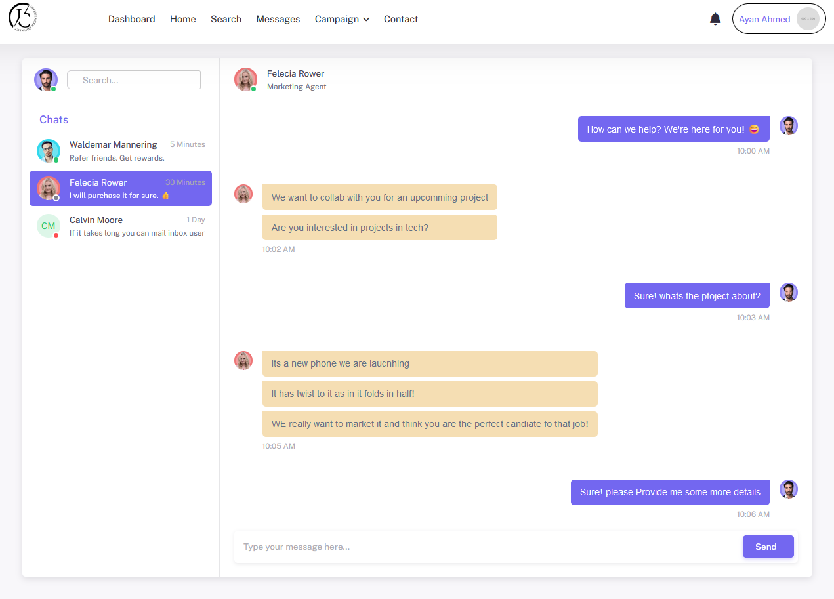

**9 Meetings held with supervisor and/or client.**

This is a self-guided practice project. No formal client meetings held. Informal feedback taken from instructors.

**11 Reference**

1. "Elasticsearch: The Definitive Guide" by Clinton Gormley and Zachary Tong. O'Reilly Media. [Online resource]
2. "Pro ASP.NET MVC 5" by Adam Freeman. Apress. [Online resource]
3. "SignalR – Real-time Application Development" by Einar Ingebrigtsen. Packt Publishing. [Online resource]

# A1B. COPY OF PROPOSAL EVALUATION COMMENTS BY JURY

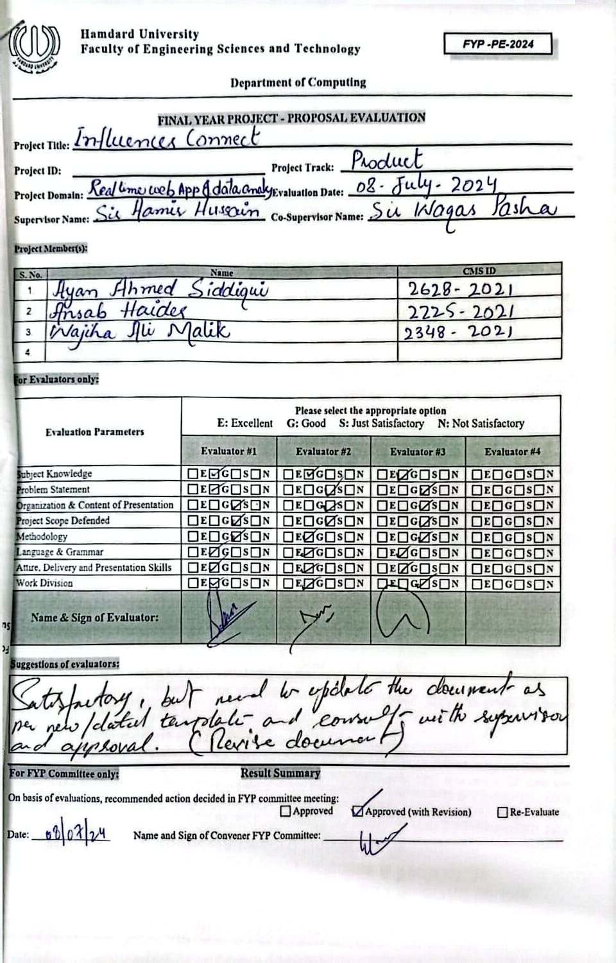

# A2. REQUIREMENT SPECIFICATIONS

Any standard template may be used, as per project need approved by Project Coordinator & Supervisor. Following is a suggestive outline.

**1. Introduction**

**1.1. Purpose of Document**

## The purpose of this document is to define the requirements and functionality of the Influencer Connect platform, purpose of which to close the gap between influencers, stakeholders and marketing agents. The document serves as a guide for developers and evaluators to ensure that everyone involved in the project can work together effectively and stays on the same page throughout the process.

**1.2. Intended Audience**

This document is intended for:

* Supervisors and evaluators to understand the project's goals and scope.
* Developers for implementation of the platform as per the requirements.
* Future maintainers for reference during updates or enhancements.

**1.3 Abbreviations**

|  |  |
| --- | --- |
| **Term** | **Description** |
| CRUD | Create, Read, Update, and Delete – Basic operations for database management. |
| UI | User Interface – The graphical layout of an application for user interaction. |
| UX | User Experience – The overall experience and satisfaction a user gets from using the platform. |
| SQL | Structured Query Language – A standard programming language for managing and querying databases. |
| HTTPS | Hypertext Transfer Protocol Secure – A protocol for secure communication over the internet. |
| SignalR | A library for adding real-time web functionality to applications. |
| WebSocket | A protocol for real-time, two-way communication between clients and servers over the web. |
| Entity Framework | An object-relational mapper (ORM) for .NET applications to interact with databases. |
| Encryption | The process of converting data into a secure format to prevent unauthorized access. |
| Stakeholders | Individuals or groups affected by or having an interest in the project, such as influencers or agents. |

**2. Overall System Description**

**2.1. Project Background**

Influencer Connect addresses the growing need for streamlined communication between influencers and marketing agents. In an era where digital marketing dominates, influencers often miss critical opportunities due to cluttered inboxes and spam filters. This platform ensures effective communication and simplifies collaboration for product promotion.

**2.2. Project Scope**

This project involves creating a platform where influencers and agents can:

* Manage direct contacts.
* Post or respond to public promotional requests.

Use a chat system for discussions. The platform will focus on usability, reliability, and solving communication inefficiencies.

**2.3. Not In Scope**

The platform will not:

* Handle financial transactions or payment processing.
* Provide content creation tools for promotions.

**2.4. Project Objectives**

* Develop a user-friendly platform for both, influencers and marketing agents.
* Reduce chances of missed promotional opportunities.
* Enable seamless communication via chat.
* Provide tools for public and private promotional requests.

**2.5. Stakeholders**

* **Primary Stakeholders**: Influencers and marketing agents.
* **Affected Groups**: Brands relying on influencers, product manufacturers, and social media managers.

**2.6. Operating Environment**

The platform will operate on:

* Web-based systems (accessible through major browsers).
* The platform will operate on major web browsers, including Chrome, Firefox, Safari, and Edge.

**2.7. System Constraints**

* Internet connectivity is required to use this platform.
* Limited storage for chat history and media files in the initial version.

**2.8. Assumptions & Dependencies**

* Users should have basic digital skills to navigate and use the platform effectively.
* The chat and notification system will rely on trusted and secure third-party libraries or services.
* The platform’s availability depends on the secure and reliable hosting services.

**3. External Interface Requirements**

**3.1. Hardware Interfaces**

The platform can be accessed through normal web browsers which required no special hardware. It can be interacted through basic input devices (keyboard and mouse) on desktop systems and touchscreens on mobile devices. The system is hosted on a server and can handle requests from client devices over the internet.

* 1. **Software Interfaces**

#### **1. User Interface (UI)**

* **Description:** A web-based user interface for marketing agents and influencers to interact with the system.
* **Technologies:** HTML, CSS, JavaScript
* **Features:**
  + Login/Sign-Up forms for user authentication.
  + Dashboards tailored for marketing agents and influencers.
  + Forms for campaign creation and management.
  + Search filters for finding influencers.
  + Notification and alert pop-ups.

#### **2. Database Interface**

* **Description:** Interaction between the application and the database for CRUD (Create, Read, Update, Delete) operations.
* **Technologies:** SQL Server with Entity Framework Core.
* **Features:**
  1. Tables for users, campaigns, influencer data, and notifications.
  2. Relational models ensuring data consistency.

#### **3. Notification System Interface**

* **Description:** A system to send notifications to users regarding campaign updates, invitations, and deadlines.
* **Technologies:**
  1. Backend: Integration with SignalR for real-time notifications.
  2. Frontend: JavaScript/JQuery hooks for displaying live updates.
  3. **Communications Interfaces**

The platform uses a secure HTTPS protocols, ensuring data integrity and security during communication over internet. It works with any standard internet connection, whether it’s through a Wi-Fi network (LAN) or mobile data. Communication between users (e.g., chats) is facilitated through WebSocket protocols which makes the conversation going smoothly without any delays.

**4. Functional Requirements**

**4.1. Functional Hierarchy**

|  |  |  |  |  |
| --- | --- | --- | --- | --- |
| **Ref #** | **Functions** | **Category** | **Attribute** | **Detail and Boundary Constraints** |
| R1.1 | Allow influencers to manage agent contact requests. | Evident | Usability | Influencers can approve or block agent contact requests easily. |
| R1.2 | Enables agents to post public promotion requests | Evident | System Response Time | Requests should appear in the platform within 5 seconds of submission. |
| R1.3 | Enable real-time chat between agents and influencers. | Hidden | Concurrent User Load | Chat should support at least 50 users chatting at the same time. |
| R1.4 | Notify users of updates (messages, requests) | Evident | Notification Speed | Notifications should be delivered to users within 5 seconds after an event occurs. |
| R1.5 | Secure user data during all operations. | Hidden | Data Security | All sensitive data must be encrypted using industry-standard protocols. |
| R1.6 | Allow users to create accounts and log in securely. | Evident | Security and Reliability | User must login securely with a response time of 5 seconds. |

|  |  |  |
| --- | --- | --- |
| **Attribute** | **Details and Boundary Constraints** | **Category** |
| **Response Time** | System should response to user actions (e.g., login, post creation) within 5 seconds. | Mandatory |
| **Concurrent User Load** | Support up to 100 active users simultaneously without effecting performance of the platform. | Mandatory |
| **Interface Metaphor** | The platform should have a simple, user-friendly design that works well on both desktop and mobile browsers. | Optional |
| **Data Security** | All user data must be encrypted while being sent and stored, ensuring privacy and safety. | Mandatory |
| **System Availability** | The platform must ensure 99.9% uptime, excluding scheduled maintenance. | Mandatory |

**4.2. Use Cases**

**4.2.1. Influencer Manages Agent Contact Requests**

* Influencers can approve or block marketing agents who request to collaborate with them.

**4.2.2. Agent Posts Public Promotion Request**

* Marketing agents can publicly post requests for promotion, which influencers can respond to.

**4.2.3. Influencer and Agent Chat**

* Influencers and agents can communicate in real-time to discuss promotion details and negotiate terms.

**4.2.4. System Sends Notifications**

* The system sends notifications to users (influencers and agents) when there are updates like new messages or requests.

**5. Non-functional Requirements**

**5.1. Performance Requirements**

* **Response Time**: The platform should load or respond to any user action, like logging in or sending messages, within 5 seconds to provide a smooth user experience.
* **Throughput**: The system must handle at least 100 users at the same time without having any performance issues.
* **Scalability**: As the platform grows, it should support up to more users at once, without any noticeable performance issues.

**5.2. Safety Requirements**

* **Data Protection**: Ensure that all user data, such as personal details and chat messages, are securely stored and transmitted using encryption methods, preventing unauthorized access or breaches.
* **System Integrity**: The platform must be designed to handle potential vulnerabilities, preventing data corruption or unauthorized changes to user accounts or system settings.
* **Secure Hosting**: The platform should be hosted on reliable, secure servers that provide protection against physical and digital threats, ensuring continuous availability and data safety.

**5.3. Security Requirements**

* **User Authentication**: The platform must have a secure login process to ensure that only authorized users (influencers, agents, administrators) can access their accounts and perform actions on the platform.
* **Data Encryption**: All sensitive data, including personal information and messages, should be securely encrypted during transfer and storage to protect against unauthorized access.
* **Role-Based Access Control**: Access to specific features (such as posting requests or viewing sensitive information) should be restricted based on the user's role to prevent unauthorized actions.

**5.4. User Documentation**

* **User Manual**: A detailed manual should be available to help Influencers and Agents learn how to use the platform and its features.
* **FAQs**: A section that answers common questions about the platform, such as how to manage agent requests or check notifications.

**6. References**

1. <https://www.researchgate.net/publication/373760614_Influencer_Marketing_with_Social_Platforms_Increasing_Brand_Awareness_and_User_Engagement>
2. <https://www.researchgate.net/publication/352120476_Understanding_influencer_marketing_The_role_of_congruence_between_influencers_products_and_consumers>
3. <https://sproutsocial.com/insights/influencer-marketing-platforms/>
4. <https://pmc.ncbi.nlm.nih.gov/articles/PMC8872418/>

# A3. DESIGN SPECIFICATIONS

**1 Introduction**

**1.1 Purpose of Document**

This document explains the design of the "Influencer Connect" platform. It is intended for project team members, supervisors, developers, and testers. The document uses an object-oriented design approach to plan and guide the development process for the platform.

**1.2 Intended Audience**

This document is intended for the following stakeholders:

* Development Team
* Supervisors (Mr. Aamir Hussain, Mr. Waqas Pasha)
* Supervisors and evaluators to understand the project's goals and scope.
* Developers for implementation of the platform as per the requirements.

Future maintainers for reference during updates or enhancements.

**1.3 Project Overview**

**Influencer Connect** is a platform designed to bridge the gap between marketing agents and influencers, providing a seamless way to create, manage, and execute influencer marketing campaigns. The system allows marketing agents to define campaign details, set target audiences, and invite influencers to collaborate, while influencers can browse campaigns, participate in tasks, and generate invoices for completed work. With role-based dashboards and campaign visibility options, the platform ensures efficiency, transparency, and streamlined workflows. Built with ASP.NET MVC and SQL Server, Influencer Connect is scalable and aims to transform how brands and influencers connect and work together.

* 1. **Scope**

This project involves creating a platform where influencers and agents can:

* Manage direct contacts.
* Post or respond to public promotional requests*.*

Use a chat system for discussions. The platform will focus on usability, reliability, and solving communication inefficiencies in influencer marketing.

**2 Design Considerations**

**2.1 Assumptions and Dependencies**

* **Integration with Third-Party APIs:**

The system assumes that third-party APIs for social media authentication (e.g., Google, Facebook, or Instagram) will be available, stable, and well-documented.

* **Hosting and Deployment:**

It is assumed that the hosting environment (e.g., Azure or AWS) will support the chosen technologies (ASP.NET MVC and SQL Server) without compatibility issues.

* **Stable Internet Connection:**

The design presumes that users will have a stable internet connection for optimal performance.

* **Frontend Compatibility:**

It is assumed that the frontend technologies and frameworks (e.g., React or Angular) will seamlessly interact with the ASP.NET MVC backend.

* **User Roles:**

The system is designed with two distinct roles (marketing agents and influencers). Any future addition of roles may require adjustments to access control logic and UI design.

**2.2 Risks and Volatile Areas**

1. **Changing Requirements:**

* **Risk:** Stakeholders might introduce new requirements, such as additional features (e.g., real-time messaging or advanced analytics).
* **Mitigation:** The system will adopt a modular design and follow SOLID principles to accommodate changes with minimal disruption. Key modules will be loosely coupled to reduce dependencies.

2. **Third-Party API Changes:**

* **Risk:** Changes or deprecation of third-party APIs (e.g., for social media login) may impact system functionality.
* **Mitigation:** Design the system to use an abstraction layer for API interactions, enabling easier replacement or updates of APIs without affecting core functionality.

3. **Scalability Challenges:**

* **Risk:** An increase in the number of users or campaigns could lead to performance bottlenecks.
* **Mitigation:** The system will be designed with scalability in mind, using caching mechanisms, optimized database queries, and load balancing strategies.

4. **Technology Adoption Risks:**

* **Risk:** Adopting new frontend frameworks or tools may introduce compatibility issues or a steep learning curve for the team.
* **Mitigation:** Conduct thorough research before adopting new tools and prioritize those with strong community support and documentation.

5. **Dependency on Team Collaboration:**

* **Risk:** Lack of synchronization between backend and frontend development teams could delay the project.
* **Mitigation:** Establish clear communication protocols, shared documentation, and regular meetings to align on design decisions and development progress.

6. **Data Growth:**

* **Risk:** A growing volume of campaign data and user records might lead to database performance issues.

**Mitigation:** Use efficient indexing strategies, partitioning, and periodic data archiving to manage data growth effectively.

**3 System Architecture**

**3.1 System Level Architecture**

At a high level, the system is decomposed into the following subsystems:

1. **User Management Subsystem**: Handles user registration, authentication, and authorization for marketing agents and influencers.
2. **Campaign Management Subsystem**: Manages campaign creation, updates, invitations, and analytics.
3. **Notification and Messaging Subsystem**: Sends real-time notifications to users and enables communication between agents and influencers.
4. **Content and Influencer Filtering Subsystem**: Provides search and filter functionalities for influencers based on specific criteria (e.g., audience demographics, content type).
5. **Data Storage Subsystem**: Stores all campaign data, user profiles, and system logs in a centralized SQL Server database.
6. **Admin Panel Subsystem**: Enables system administrators to monitor, approve, and manage platform activities.

**Relationships between Elements**:

* Users interact with the system through the User Interface (UI), accessing features exposed by the Business Logic Layer (BLL).
* The BLL coordinates with the Data Access Layer (DAL) to fetch or update data in the database.
* External systems, such as email or SMS APIs, are integrated via middleware.

**Interfaces to External Systems**:

* APIs for third-party social media platforms to fetch influencer details.
* Payment gateways for handling transactions.

**Global Design Strategies**:

* Centralized error handling with logging for traceability.

Security practices like token-based authentication and input validation for data integrity.

**3.2 Software Architecture**

The software architecture for this system is based on the ASP.NET MVC framework. It organizes the application into three main layers:

1. **View Layer (User Interface Layer):**
   * Responsible for presenting data to the user.
   * Handles input and user interactions, which are then forwarded to the Controller.
   * Contains Razor Views and HTML content.
2. **Controller Layer (Middle Tier):**
   * Acts as an intermediary between the View and the Model (Database layer).
   * Processes user requests, handles application logic, and determines the appropriate View to display.
   * Ensures smooth interaction between the View and Data Access layers.
3. **Model Layer (Data Access Layer):**
   * Communicates directly with the database using Entity Framework.
   * Manages data retrieval, storage, and business rules.

**Interaction Flow:**

* The user interacts with the **View**, triggering a request.
* The **Controller** processes the request, applies logic, and interacts with the **Model** to fetch or update data.

Data is passed back to the **View** through the **Controller**, ensuring the user sees the latest updates.

**4 Design Strategy**

The design strategy for the Influencer Connect system focuses on achieving scalability, maintainability, and user-centric functionality. Key design strategies and decisions impacting the organization of the system and its high-level structures are outlined below:

#### ****4.1 Future System Extension or Enhancement****

The system is designed with modularity in mind, using the ASP.NET MVC framework to separate concerns across the application. Each component (Model, View, and Controller) can be extended independently to add new features or improve existing ones without disrupting the overall functionality. For example:

* Adding new user roles or campaign features will require modifications to specific controllers and views.
* Additional data attributes or new tables can be integrated into the database layer with minimal disruption.

#### ****4.2 System Reuse****

Reusable components and patterns, such as shared partial views and reusable helper methods, are utilized across the application to reduce development effort and ensure consistency. Dependency Injection (DI) is implemented for services, promoting reusability and testability across various layers of the system.

#### ****4.3 User Interface Paradigms****

The system employs a responsive design to provide an intuitive user interface across multiple devices. The View Layer relies on Razor templates, Bootstrap, and JavaScript for dynamic content and enhanced user interaction. Efforts are made to maintain consistency in the UI for both marketing agents and influencers.

#### ****4.4 Data Management****

* **Storage**: The database layer uses SQL Server for secure, efficient, and reliable data storage. Entity Framework (EF) handles object-relational mapping (ORM), simplifying interactions between the application and the database.
* **Distribution**: Data access is centralized through the Model layer, ensuring consistent and secure data retrieval and manipulation.
* **Persistence**: Campaign data, messages, and notifications are persisted in the database, ensuring that users can resume their work seamlessly. Soft delete mechanisms are implemented for historical records.

#### ****4.5 Concurrency and Synchronization****

The system minimizes concurrency issues by implementing transaction handling in the database layer. Entity Framework ensures that concurrent data modifications do not result in conflicts or data corruption. For real-time messaging or notifications, SignalR can be integrated to manage concurrent updates effectively.

**5 Detailed System Design**

**5.1 Database Design**

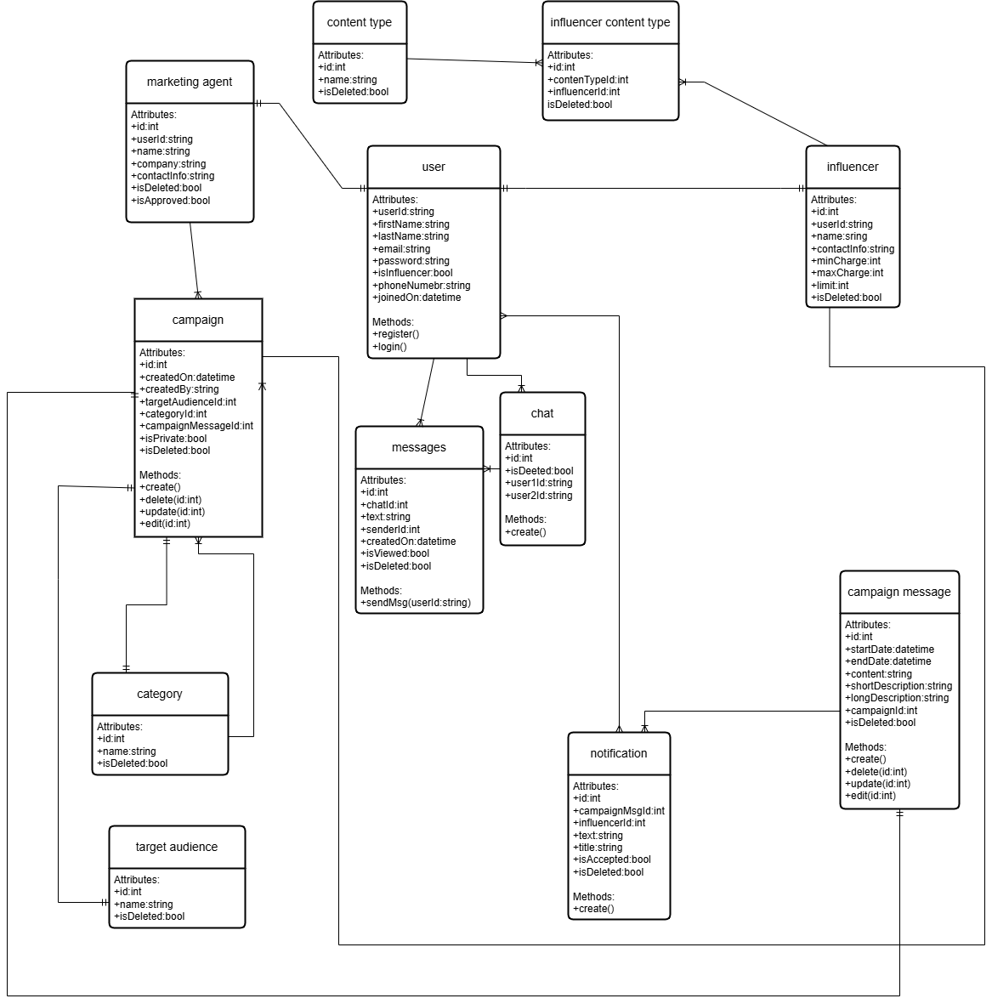

**5.1.1 ER Diagram**

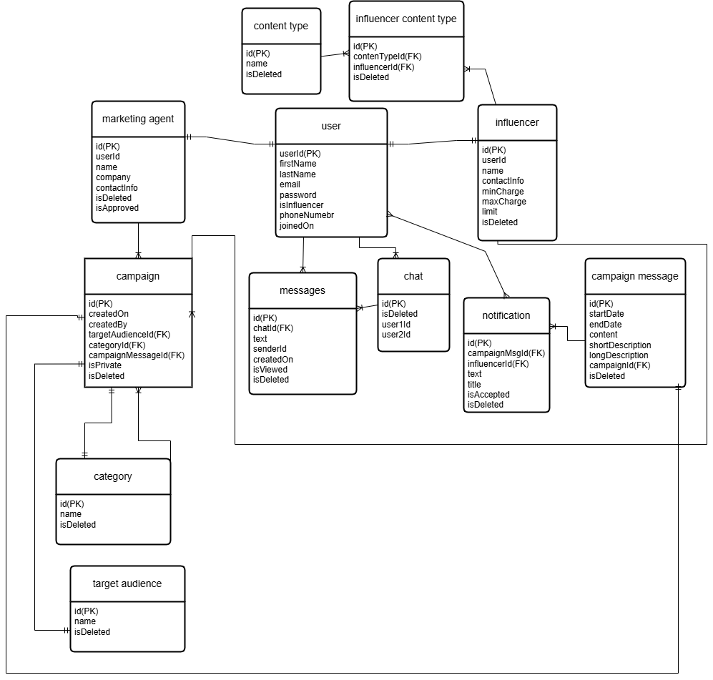

**5.1.2 Data Dictionary**

**5.1.2.1 Data 1 User**

|  |  |  |  |  |  |  |  |
| --- | --- | --- | --- | --- | --- | --- | --- |
| User | | | | | | | |
| **Name** | | User | | | | | |
| **Alias** | |  | | | | | |
| **Where-used/how-used** | | Used to store basic information about platform users (influencers and agents).  Acts as input for managing campaigns, chats, and notifications. | | | | | |
| **Content description** | | Represents registered users in the system. | | | | | |
|  | | | | | | | |
| **Column Name** | **Description** | | **Type** | **Length** | **Null able** | **Default Value** | **Key Type** |
| UserId | Unique identifier for each user | | Varchar | 255 | NO | Auto Increment | PK |
| FirstName | First name of user | | Varchar | 255 | NO |  |  |
| LastName | Last name of user | | Varchar | 255 | NO |  |  |
| Email | Email of user | | Varchar | 255 | NO |  |  |
| Password | Password of user | | Varchar | 255 | NO |  |  |
| IsInfluencer |  | | bool | 1 | NO |  |  |

**5.1.2.2 Data 2 Influencer**

|  |  |  |  |  |  |  |  |
| --- | --- | --- | --- | --- | --- | --- | --- |
| Influencer | | | | | | | |
| **Name** | | Influencer | | | | | |
| **Alias** | |  | | | | | |
| **Where-used/how-used** | | * Used in campaign management to assign and track campaigns for influencers. * Referenced in search and filtering functionality for agents looking for influencers | | | | | |
| **Content description** | | Represents detailed model of Influencer | | | | | |
|  | | | | | | | |
| **Column Name** | **Description** | | **Type** | **Length** | **Null able** | **Default Value** | **Key Type** |
| Id | Unique identifier for each user | | int |  | NO | Auto Assigned | PK |
| UserId | References the associated user in the **User** table. | | Varchar | 255 | NO |  |  |
| Name | Full Name of Influencer | | Varchar | 255 | NO |  |  |
| MinCharge | Min charge for a campaign | | Int | 255 | NO |  |  |
| MaxCharge | Max charge for a campaign | | Int | 255 | NO |  |  |
| Limit | Represents No of Invites allowed | | int | 1 | NO |  |  |

**5.1.2.3 Data 3 Marketing Agent**

|  |  |  |  |  |  |  |  |
| --- | --- | --- | --- | --- | --- | --- | --- |
| Marketing Agent | | | | | | | |
| **Name** | | Marketing Agent | | | | | |
| **Alias** | | Agent | | | | | |
| **Where-used/how-used** | | * Used to store and manage detailed profiles of marketing agents on the platform. * Acts as a reference in campaigns to assign agents or track their collaborations with influencers. * Facilitates influencers in identifying and connecting with marketing agents. * Used in approval processes to ensure only verified agents participate on the platform (IsApproved flag). * Enables filtering of active agents by excluding those flagged as deleted (IsDeleted flag). * Provides contact and company information to influencers during campaign planning and execution. | | | | | |
| **Content description** | | Represents detailed model of Marketing Agent | | | | | |
|  | | | | | | | |
| **Column Name** | **Description** | | **Type** | **Length** | **Null able** | **Default Value** | **Key Type** |
| Id | Unique identifier for each agent | | int | 255 | NO | Auto Increment | PK |
| UserId | References the associated user in User | | Varchar | 255 | NO |  |  |
| Company | Name of Company | | Varchar | 255 | NO |  |  |
| ContactNo | Contact info of agent | | Varchar | 255 | NO |  |  |
| IsDeleted | Indicates whether the agent's profile is deleted or inactive. | | bool | 255 | NO |  |  |
| IsApproved | Indicates whether the agent's account is approved for use (e.g., after admin verification). | | bool | 1 | NO |  |  |

**5.1.2.4 Data 4 Campaign**

|  |  |  |  |  |  |  |  |
| --- | --- | --- | --- | --- | --- | --- | --- |
| Campaign | | | | | | | |
| **Name** | | Campaign | | | | | |
| **Alias** | |  | | | | | |
| **Where-used/how-used** | | * Stores and manages detailed information about promotional campaigns on the platform. * Used to link marketing agents with influencers and specify campaign details like target audience, category, and messaging * Enables marketing agents to create and manage campaigns. * Connects influencers with relevant campaigns based on target audience and category. | | | | | |
| **Content description** | | Represents promotional campaigns created by marketing agents. It includes information about the campaign's target audience, category, and messaging. Campaigns can be public or private and are linked to marketing agents and influencers for collaboration and tracking | | | | | |
|  | | | | | | | |
| **Column Name** | **Description** | | **Type** | **Length** | **Null able** | **Default Value** | **Key Type** |
| Id | Unique identifier for each agent | | int | 255 | NO | Auto Increment | PK |
| CreatedOn | Date and time the campaign was created | | DateTime |  | NO |  |  |
| CreatedBy | ID of the user who created the campaign. | | Varchar | 255 | NO |  |  |
| TargetAudience | ID linking to the target audience details. | | int | 255 | NO |  | FK |
| CategoryId | ID linking to the campaign category | | int | 255 | NO |  | FK |
| ICampaignMessageId | ID linking to the campaign message details. | | bool | 1 | NO |  | FK |
| IsPrivate | |  | | --- | | Indicates if the campaign is private. |  |  | | --- | |  | | | bool |  | NO |  |  |
| IsDeleted | Indicates if the campaign is deleted. | | bool |  | NO | 0 |  |

**5.1.2.5 Data 5 CampaignMessage**

|  |  |  |  |  |  |  |  |
| --- | --- | --- | --- | --- | --- | --- | --- |
| CampaignMessage | | | | | | | |
| **Name** | | CampaignMessage | | | | | |
| **Alias** | |  | | | | | |
| **Where-used/how-used** | | * Stores and manages the message content associated with a campaign. * Used in campaign creation and display to define the promotional message and campaign descriptions. * Acts as input for generating promotional materials and communications. * Provides a detailed message (Content, ShortDescription, LongDescription) for campaigns. * Tracks the campaign's active period using StartDate and EndDate. * Links to campaigns through the CampaignId property. | | | | | |
| **Content description** | | Represents the message or promotional content for a specific campaign. | | | | | |
|  | | | | | | | |
| **Column Name** | **Description** | | **Type** | **Length** | **Null able** | **Default Value** | **Key Type** |
| Id | Unique identifier for each Campaign Message | | int | 255 | NO | Auto Increment | PK |
| StartDate | Start date of the campaign message's validity. | | DateTime |  | NO |  |  |
| EndDate | End date of the campaign message's validity.. | | DateTime |  | NO |  |  |
| Content | The main content of the campaign message.. | | Varchar | 255 | NO |  |  |
| ShortDescription | A brief description of the campaign message. | | Varchar | 255 | NO |  |  |
| LongDiscription | A detailed description of the campaign message. | | Varchar | 255 | NO |  |  |
| CampiagnId | |  |  |  | | --- | --- | --- | | |  | | --- | | ID linking the message to its associated campaign. |  |  | | --- | |  | |  |  | | --- | |  | | | bool |  | NO |  | FK |
| IsDeleted | Indicates if the campaign is deleted. | | bool |  | NO | 0 |  |

**5.1.2.6 Data 6 Category**

|  |  |  |  |  |  |  |  |
| --- | --- | --- | --- | --- | --- | --- | --- |
| Category | | | | | | | |
| **Name** | | Category | | | | | |
| **Alias** | |  | | | | | |
| **Where-used/how-used** | | * Used to categorize campaigns for better organization and filtering. * Provides a classification system for marketing agents and influencers to select or browse relevant campaigns. * Enables marketing agents to assign a category to their campaigns during creation. * Helps influencers filter campaigns by their category. | | | | | |
| **Content description** | | Represents different categories available on the platform to classify campaigns. | | | | | |
|  | | | | | | | |
| **Column Name** | **Description** | | **Type** | **Length** | **Null able** | **Default Value** | **Key Type** |
| Id | Unique identifier for each Category | | int |  | NO | Auto Increment | PK |
| Name | Name of the category... | | Varchar | 255 | NO |  |  |
| IsDeleted | Indicates if the category is deleted. | | bool |  | NO | 0 |  |

**5.1.2.7 Data 7 Chat**

|  |  |  |  |  |  |  |  |
| --- | --- | --- | --- | --- | --- | --- | --- |
| **Chat** | | | | | | | |
| **Name** | | Chat | | | | | |
| **Alias** | |  | | | | | |
| **Where-used/how-used** | | * Stores and manages chat sessions between two users (influencers and marketing agents). * Acts as a reference to retrieve messages exchanged in a specific chat session. * Facilitates direct communication between users (e.g., influencers and agents). * Tracks and links messages between the two users through the Messages property. | | | | | |
| **Content description** | | Represents a chat session between two users (User1 and User2). Each chat session is uniquely identified and contains the messages exchanged between the users. | | | | | |
|  | | | | | | | |
| **Column Name** | **Description** | | **Type** | **Length** | **Null able** | **Default Value** | **Key Type** |
| Id | Unique identifier for the chat session. | | int |  | NO | Auto Increment | PK |
| UserId1 | ID of the first user in the chat session. | | Varchar | 255 | NO |  | FK |
| UserId2 | ID of the second user in the chat session. | | Varchat | 255 | NO |  | FK |

**5.1.2.8 Data 8 Messages**

|  |  |  |  |  |  |  |  |
| --- | --- | --- | --- | --- | --- | --- | --- |
| **Messages** | | | | | | | |
| **Name** | | Messages | | | | | |
| **Alias** | |  | | | | | |
| **Where-used/how-used** | | * Stores individual messages exchanged in a chat session * Enables users (influencers and marketing agents) to send and receive messages through the platform. * Tracks the sender, timestamp, and read status of each message. * Links messages to a specific chat session using the ChatId property. | | | | | |
| **Content description** | | Represents individual messages exchanged between two users in a chat session. | | | | | |
|  | | | | | | | |
| **Column Name** | **Description** | | **Type** | **Length** | **Null able** | **Default Value** | **Key Type** |
| Id | Unique identifier for the message. | | int |  | NO | Auto Increment | PK |
| ChatId | ID linking the message to a specific chat. | | int |  | NO |  | FK |
| SenderId | ID of the user who sent the message. | | Varchar | 255 | NO |  | FK |
| CreatedOn | Timestamp indicating when the message was sent. | | DateTime |  |  |  |  |
| IsViewed | Indicates if the message has been read. | | Bool |  |  |  |  |
| Text | The content of the message. | | varchar | 255 |  |  |  |

**5.1.2.9 Data 9 TargetAudience**

|  |  |  |  |  |  |  |  |
| --- | --- | --- | --- | --- | --- | --- | --- |
| TargetAudience | | | | | | | |
| **Name** | | TargetAudience | | | | | |
| **Alias** | |  | | | | | |
| **Where-used/how-used** | | * Stores and manages information about the intended audience for a campaign. * Used in campaigns to identify and define the target demographic or interest group. * Enables marketing agents to specify the target audience for their campaigns during creation. * Assists influencers in finding campaigns relevant to their audience demographics. | | | | | |
| **Content description** | | Represents a target audience or demographic group for campaigns. | | | | | |
|  | | | | | | | |
| **Column Name** | **Description** | | **Type** | **Length** | **Null able** | **Default Value** | **Key Type** |
| Id | Unique identifier for each TargetAudience | | int |  | NO | Auto Increment | PK |
| Name | Name of TargetAudience | | Varchar | 255 | NO |  |  |
| IsDeleted | Indicates if the targetaudience is deleted. | | bool |  | NO | 0 |  |

**5.1.2.10 Data 10 ContentType**

|  |  |  |  |  |  |  |  |
| --- | --- | --- | --- | --- | --- | --- | --- |
| ContentType | | | | | | | |
| **Name** | | ContentType | | | | | |
| **Alias** | |  | | | | | |
| **Where-used/how-used** | | * Used to categorize the type of content that an influencer can create or share. * Linked to influencer content preferences and campaign requirements. * Allows influencers to select or define the type of content they can create, such as video, blog post, image, etc. * Helps marketing agents identify content types needed for campaigns. | | | | | |
| **Content description** | | Represents a content type, such as video, image, or article that influencers can create and share. | | | | | |
|  | | | | | | | |
| **Column Name** | **Description** | | **Type** | **Length** | **Null able** | **Default Value** | **Key Type** |
| Id | Unique identifier for each ContentType | | int |  | NO | Auto Increment | PK |
| Name | Name of ContentType | | Varchar | 255 | NO |  |  |
| IsDeleted | Indicates if the contentType is deleted. | | bool |  | NO | 0 |  |

**5.1.2.11 Data 11 InfluencerContentType**

|  |  |  |  |  |  |  |  |
| --- | --- | --- | --- | --- | --- | --- | --- |
| InfluencerContentType | | | | | | | |
| **Name** | | InfluencerContentType | | | | | |
| **Alias** | |  | | | | | |
| **Where-used/how-used** | | * Tores the association between influencers and the content types they can create or specialize in. * Links influencers with specific content types (e.g., video, image, blog) for campaign matching. * Allows influencers to specify which content types they are capable of creating. * Helps marketing agents and campaigns identify the content types associated with influencers. | | | | | |
| **Content description** | | Represents the relationship between an influencer and the content types they can produce. | | | | | |
|  | | | | | | | |
| **Column Name** | **Description** | | **Type** | **Length** | **Null able** | **Default Value** | **Key Type** |
| Id | Unique identifier for the influencer-content type relationship. | | int |  | NO | Auto Increment | PK |
| InfluencerId | ID of the influencer associated with the content type. | | Varchar | 255 | NO |  | FK |
| IsDeleted | Indicates if the influencer-content type relationship is deleted. | | bool |  | NO | 0 |  |
| ContentTypeId | ID of the content type associated with the influencer. | |  |  | NO |  | FK |

**5.1.2.12 Data 12 Notification**

|  |  |  |  |  |  |  |  |
| --- | --- | --- | --- | --- | --- | --- | --- |
| Notification | | | | | | | |
| **Name** | | Notification | | | | | |
| **Alias** | |  | | | | | |
| **Where-used/how-used** | | * Stores notifications related to campaigns and their messages, specifically for influencers. * Used to alert influencers about campaign updates, messages, and decisions (e.g., acceptance or rejection). * Allows the platform to send notifications to influencers about the status of campaign messages. * Tracks whether the notification was accepted or rejected by the influencer. | | | | | |
| **Content description** | | Represents a notification that informs an influencer about a campaign message, providing details such as the message's title, content, and the influencer's response status (accepted/rejected). Notifications are used to alert users about important updates or actions required for campaigns. | | | | | |
|  | | | | | | | |
| **Column Name** | **Description** | | **Type** | **Length** | **Null able** | **Default Value** | **Key Type** |
| Id | Unique identifier for the notification. | | int |  | NO | Auto Increment | PK |
| CampaignMsgId | ID of the associated campaign message. | | int |  | NO |  | FK |
| InfluencerId | ID of the influencer who is receiving the notification. | | int |  | NO | 0 | FK |
| Text | Title of the notification.. | | varchar | 255 | NO |  |  |
| IsAccepted | |  | | --- | |  |  |  | | --- | | Indicates if the influencer has accepted the campaign message. | | | bool |  | YES |  |  |

**5.2 Application Design**

**5.2.1 Sequence Diagram**

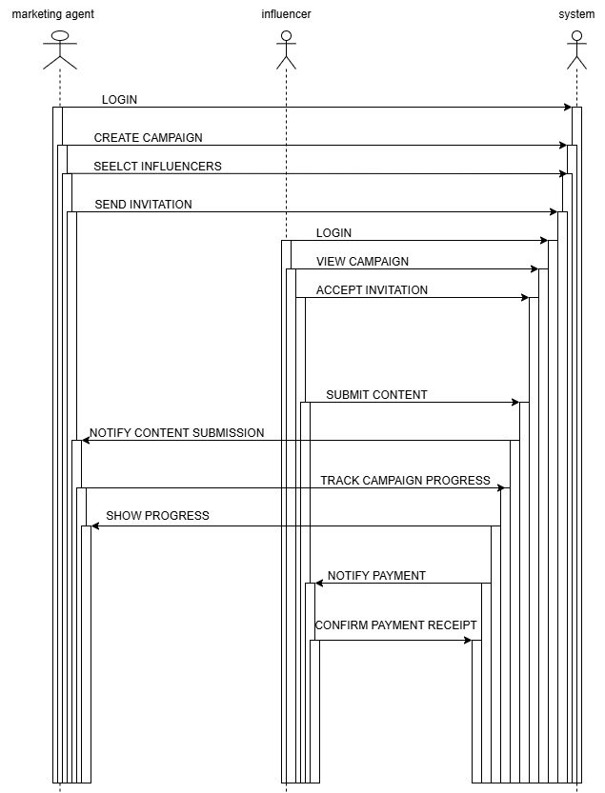

**5.2.2 State Diagram**

**5.2.2.1 State Diagram 1**

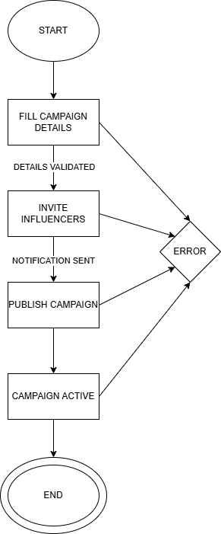

**5.2.2.2 State Diagram 2**

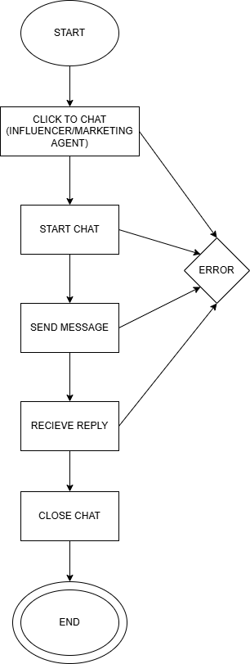

**5.2.2.3 State Diagram 3**

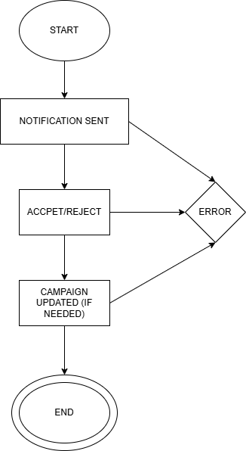

**5.2.2.4 State Diagram 4**



**6 References**

1. <https://www.researchgate.net/publication/373760614_Influencer_Marketing_with_Social_Platforms_Increasing_Brand_Awareness_and_User_Engagement>
2. <https://www.researchgate.net/publication/352120476_Understanding_influencer_marketing_The_role_of_congruence_between_influencers_products_and_consumers>
3. <https://sproutsocial.com/insights/influencer-marketing-platforms/>
4. <https://pmc.ncbi.nlm.nih.gov/articles/PMC8872418/>

# A4. OTHER TECHNICAL DETAIL DOCUMENTS

## Test Cases Document

**Project Title:** InfluencerConnect  
**Prepared By:** Ayan Ahmed Siddiqui, Ansab Haider, Wajiha Ali Malik  
**Start Date:** 3-May-2025  
**End Date:** 5-May-2025

|  |  |  |  |  |
| --- | --- | --- | --- | --- |
| **S. No** | **Description** | **Test Engineer** | **Start Date** | **End Date** |
| 1 | Login Screen | Ayan Ahmed Siddiqui | 01-May-25 | 01-May-25 |
| 2 | Registration Screen | Wajiha Ali Malik | 01-May-25 | 01-May-25 |
| 3 | Influencer Dashboard | Ansab Haider | 02-May-25 | 02-May-25 |
| 4 | Marketing Agent Dashboard | Ayan Ahmed Siddiqui | 02-May-25 | 02-May-25 |
| 5 | Campaign Creation | Ansab Haider | 03-May-25 | 03-May-25 |
| 6 | Influencer Search & Filtering | Wajiha Ali Malik | 03-May-25 | 03-May-25 |
| 7 | Invitation System | Ayan Ahmed Siddiqui | 04-May-25 | 04-May-25 |
| 8 | Real-time Messaging | Ansab Haider | 04-May-25 | 04-May-25 |
| 9 | Notification System | Wajiha Ali Malik | 05-May-25 | 05-May-25 |
| 10 | Admin Panel (User & Role Access) | Ayan Ahmed Siddiqui | 05-May-25 | 05-May-25 |

**Test Case**

**Project Name:** Plagiarism Detection System for Urdu Language  
**Iteration No:** 1  
**Module Name:** Login API  
**Date:** 10-April-2025  
**Test Case ID:** TC-001  
**Test Engineer:** Syed Ahmed Ali  
**Test Case Description:** This test case verifies the login API functionality using valid, invalid, and empty credentials. It ensures the system allows authenticated access and handles errors correctly.

|  |  |  |  |  |  |
| --- | --- | --- | --- | --- | --- |
| **S. No** | **Steps** | **Input Data** | **Expected Result** | **Actual Result** | **Pass/Fail** |
| TC-1 | Enter Email, Password, Click Login | ayan@influencerconnect.com / 1234 | User redirected to dashboard | User redirected to dashboard | Pass |
| TC-2 | Enter incorrect password and attempt login | ayan@influencerconnect.com / xyz | Show login error | Show login error | Pass |
| TC-3 | Submit empty fields | (blank) | Validation error | Validation error | Pass |
| TC-4 | Enter non-registered email and submit | test@unknown.com / abc | Show login error | Show login error | Pass |

**Module Name:** User Registration  
**Date:** 01-May-2025  
**Test Case ID:** TC-002  
**Test Engineer:** Wajiha Ali Malik  
**Test Case Description:** Verify user registration functionality with valid and invalid inputs

|  |  |  |  |  |  |
| --- | --- | --- | --- | --- | --- |
| **S. No** | **Steps** | **Input Data** | **Expected Result** | **Actual Result** | **Pass/Fail** |
| TC-1 | Enter Name, Email, Password, Confirm Pass | Name: John | User should be registered and redirected to login page | User registered and redirected | Pass |
| Email: john@mail.com |
| Password: Test@123 |
| Confirm: Test@123 |
| TC-2 | Leave Email field blank | Name: John | Error message: "Email is required" | Error shown | Pass |
| Email: (blank) |
| Password: Test@123 |
| TC-3 | Enter mismatched passwords | Name: John | Error message: "Passwords do not match" | Error shown | Pass |
| Email: john@mail.com |
| Password: Test@123 |
| Confirm: Test@124 |
| TC-4 | Use duplicate email | Email already exists in database | Error message: "Email already exists" | Error shown | Pass |

**Module Name:** Campaign Creation  
**Date:** 02-May-2025  
**Test Case ID:** TC-003  
**Test Engineer:** Ansab Haider  
**Test Case Description:** Verify that a marketing agent can create a campaign with valid and invalid data

|  |  |  |  |  |  |
| --- | --- | --- | --- | --- | --- |
| **S. No** | **Steps** | **Input Data** | **Expected Result** | **Actual Result** | **Pass/Fail** |
| TC-1 | Fill all fields correctly and submit | Content: New Phone Launch | Campaign should be created and listed | Campaign created successfully | Pass |
| Start Date: 05-May-2025 |
| End Date: 15-May-2025 |
| Budget: 100000 PKR |
| TC-2 | Leave required field (Content) empty | Content: (blank) | Error message: "Content is required" | Error shown | Pass |
| Other fields filled |
| TC-3 | End date before start date | Start Date: 10-May-2025 | Error message: "End date must be after start" | Error shown | Pass |
| End Date: 05-May-2025 |
| TC-4 | Enter non-numeric budget | Budget: "Ten Thousand" | Error message: "Invalid budget format" | Error shown | Pass |
| TC-5 | Try submitting without being approved agent | All valid fields | Error message: "Account not approved" | Error shown | Pass |

**Module Name:** Messaging System  
**Date:** 03-May-2025  
**Test Case ID:** TC-004  
**Test Engineer:** Wajiha Ali Malik  
**Test Case Description:** Validate real-time messaging between Influencer and Marketing Agent using SignalR

|  |  |  |  |  |  |
| --- | --- | --- | --- | --- | --- |
| **S. No** | **Steps** | **Input Data** | **Expected Result** | **Actual Result** | **Pass/Fail** |
| TC-1 | Send a message from Influencer to Agent | Message: “Hi, I'm interested in your campaign.” | Message appears instantly in Agent’s chat window | Delivered within 1 second | Pass |
| TC-2 | Send message when other user is offline | Message: “Hey, let's connect.” | Message delivered once user comes online | Delivered on next login | Pass |
| TC-3 | Try sending a message as unapproved Agent | Logged in as unapproved Agent | Error shown: “Account not approved” | Access denied to chat | Pass |
| TC-4 | Open chat thread with existing conversation | Clicked on existing chat from “My Chats” | All past messages are loaded correctly | Messages rendered correctly | Pass |
| TC-5 | Send an empty message | Message: (blank) | Error: “Message cannot be empty” | Error shown | Pass |
| TC-6 | Multiple users messaging at once | 3 users active and exchanging messages simultaneously | All messages sent/received in real-time | No delays or overlap | Pass |

**Module Name:** Invitation System  
**Date:** 04-May-2025  
**Test Case ID:** TC-005  
**Test Engineer:** Ansab Haider  
**Test Case Description:** Validate that Marketing Agents can send and manage invitations to influencers, and influencers can accept or reject them.

|  |  |  |  |  |  |
| --- | --- | --- | --- | --- | --- |
| **S. No** | **Steps** | **Input Data** | **Expected Result** | **Actual Result** | **Pass/Fail** |
| TC-1 | Agent sends invitation to influencer | Select influencer from list → Click "Invite" | Invitation sent successfully | Invitation created and saved in DB | Pass |
| TC-2 | Agent tries to invite without selecting any influencer | Click "Invite" button with no checkboxes selected | Error: “Please select at least one influencer” | Proper error displayed | Pass |
| TC-3 | Influencer accepts the invitation | Click "Accept" button on received invite | Status changes to Accepted, reflected in UI and database | Status updated to Accepted | Pass |
| TC-4 | Influencer rejects the invitation | Click "Reject" button | Status changes to Rejected, invitation removed from view | Invitation marked as rejected | Pass |
| TC-5 | Unapproved Agent tries to send invitations | Logged in as unapproved agent | Access denied or button hidden | Button hidden; action blocked | Pass |
| TC-6 | Duplicate invitation prevention | Try to invite same influencer for same campaign | Error: “Already invited” | Prevented with error shown | Pass |

**Module Name:** Admin Panel – Marketing Agent Approval **Date:** 04-May-2025  
**Test Case ID:** TC-006  
**Test Engineer:** Ayan Ahmed Siddiqui  
**Test Case Description:** Validate that admin can approve/reject newly registered marketing agents and restrict their system access based on approval.

|  |  |  |  |  |  |
| --- | --- | --- | --- | --- | --- |
| **S. No** | **Steps** | **Input Data** | **Expected Result** | **Actual Result** | **Pass/Fail** |
| TC-1 | Open Admin Panel and view list of pending agents | N/A | All unapproved marketing agents are listed | Unapproved agents displayed | Pass |
| TC-2 | Approve a pending agent | Click "Approve" on an unapproved agent | Status updates to Approved; agent can now create campaigns | Status updated; access granted | Pass |
| TC-3 | Reject a pending agent | Click "Reject" | Status updates to Rejected; agent cannot access core features | Status updated to Rejected | Pass |
| TC-4 | Approved agent logs in | Approved account credentials | Redirected to dashboard with campaign access | Accessed dashboard successfully | Pass |
| TC-5 | Unapproved agent tries to create a campaign | Logged in as unapproved user | Error message: "Your account is not yet approved" | Message shown; create page blocked | Pass |
| TC-6 | Unapproved agent tries to use messaging system | Logged in as unapproved user | Access denied to messaging system | Chat hidden; access denied | Pass |

**Module Name:** Influencer Search & Filter  
**Date:** 05-May-2025  
**Test Case ID:** TC-007  
**Test Engineer:** Wajiha Ali Malik  
**Test Case Description:** Verify that influencers can be searched and filtered based on multiple criteria such as category, content type, keyword, and price range.

|  |  |  |  |  |  |
| --- | --- | --- | --- | --- | --- |
| **S. No** | **Steps** | **Input Data** | **Expected Result** | **Actual Result** | **Pass/Fail** |
| TC-1 | Filter influencers by category | Select category: "Tech" | List displays only influencers belonging to "Tech" category | Correct filtered results shown | Pass |
| TC-2 | Filter influencers by content type | Select "Stories" and "Reels" | Influencers with selected content types appear | Results updated correctly | Pass |
| TC-3 | Apply min/max ad price filter | Min: 1000, Max: 3000 | Influencers within price range are listed | Prices filtered as expected | Pass |
| TC-4 | Search influencers using a keyword | Enter keyword: "Ali" | All influencer names containing “Ali” are shown | Search results correct | Pass |
| TC-5 | Apply combined filters (category + content type + price + keyword) | "Beauty", "Videos", Min: 2000, Max: 4000, keyword: "Khan" | Narrowed down results matching all filters | Multicriteria filter works as expected | Pass |
| TC-6 | Search with no matching influencers | Keyword: "xyzabc" | Message shown: “No influencers found” | Message displayed correctly | Pass |

**Module Name:** Campaign Listing with Pagination  
**Date:** 06-May-2025  
**Test Case ID:** TC-008  
**Test Engineer:** Ansab Haider  
**Test Case Description:** Verify that campaign pagination works correctly and limits the number of campaigns shown per page to 9.

|  |  |  |  |  |  |
| --- | --- | --- | --- | --- | --- |
| **S. No** | **Steps** | **Input Data** | **Expected Result** | **Actual Result** | **Pass/Fail** |
| TC-1 | Load Campaign Page | Go to Campaign List Page | First 9 campaigns are displayed | Displayed 9 campaigns | Pass |
| TC-2 | Navigate to next page | Click on page number 2 | Next set of 9 campaigns is loaded | Next 9 campaigns shown | Pass |
| TC-3 | Navigate to a page with fewer than 9 campaigns | Navigate to last page (e.g., 5) | Remaining campaigns (less than 9) displayed | 3 campaigns shown (as expected) | Pass |
| TC-4 | Navigate back to previous page | Click on page number 1 | Returns to the first 9 campaigns | First 9 campaigns reloaded | Pass |
| TC-5 | Use browser back button after navigation | Click browser back | Returns to previous pagination state | Correct page state maintained | Pass |
| TC-6 | Combine pagination with filters | Filter by “Tech” category + page 2 | Displays 9 filtered “Tech” campaigns from offset | Filtered + paginated results OK | Pass |

**Module Name:** Invoice Generation  
**Date:** 07-May-2025  
**Test Case ID:** TC-009  
**Test Engineer:** Ayan Ahmed Siddiqui  
**Test Case Description:** Verify that influencers can generate invoices after accepting a campaign and the data is correctly reflected.

|  |  |  |  |  |  |
| --- | --- | --- | --- | --- | --- |
| **S. No** | **Steps** | **Input Data** | **Expected Result** | **Actual Result** | **Pass/Fail** |
| TC-1 | Navigate to accepted campaign list | Influencer logs in and views accepted campaigns | Accepted campaigns are listed with invoice option available | Accepted campaigns shown | Pass |
| TC-2 | Generate invoice for a campaign | Click "Generate Invoice" for Campaign A | Invoice preview is displayed with correct campaign and influencer details | Invoice preview generated correctly | Pass |
| TC-3 | Submit invoice | Click "Submit Invoice" | Invoice is saved and marked as submitted | Invoice saved and status updated | Pass |
| TC-4 | Generate invoice for a campaign already invoiced | Click "Generate Invoice" again | Error or message: "Invoice already submitted for this campaign" | Message displayed | Pass |
| TC-5 | View generated invoice | Navigate to "My Invoices" | List of all submitted invoices is displayed | Invoices listed correctly | Pass |
| TC-6 | Generate invoice with missing campaign data (edge case) | Campaign data deleted by admin | Error message or graceful handling with proper alert | Error handled gracefully | Pass |

**Module Name:** Admin Panel – Marketing Agent Approval  
**Date:** 08-May-2025  
**Test Case ID:** TC-010  
**Test Engineer:** Ansab Haider  
**Test Case Description:** Verify that an admin can view pending marketing agent registrations and approve or reject them.

|  |  |  |  |  |  |
| --- | --- | --- | --- | --- | --- |
| **S. No** | **Steps** | **Input Data** | **Expected Result** | **Actual Result** | **Pass/Fail** |
| TC-1 | Log in as admin | Valid admin credentials | Admin dashboard is displayed | Dashboard loaded | Pass |
| TC-2 | Navigate to “Pending Agents” section | Click on “Pending Agents” | List of unapproved agents appears | Pending agents listed | Pass |
| TC-3 | Click “Approve” on a pending agent | Agent ID = 1204 | Agent status updated to “Approved” in database | Status updated correctly | Pass |
| TC-4 | Click “Reject” on a pending agent | Agent ID = 1205 | Agent status updated to “Rejected” or marked deleted | Status updated correctly | Pass |
| TC-5 | Try accessing campaign creation as unapproved agent | Login as unapproved agent | “Not Approved” message displayed and access blocked | Access correctly blocked | Pass |
| TC-6 | Verify approved agent now sees campaign creation UI | Login as approved agent | Campaign creation form visible | Campaign form rendered | Pass |

## UI/UX Detail Document

* 1. The platform's homepage introduces the service and highlights its core purpose—connecting influencers and agents for streamlined collaboration.

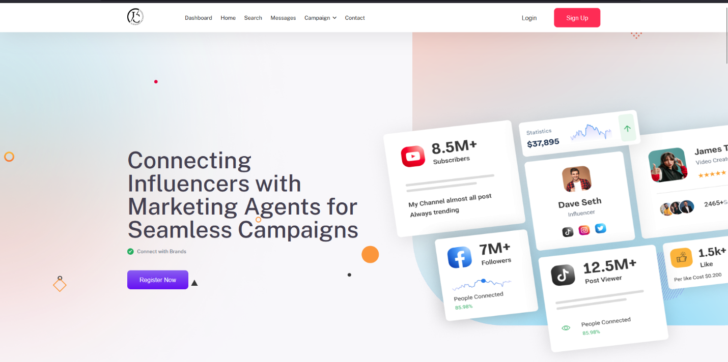

* 1. The login screen where existing users (influencers or agents) can access their accounts securely.

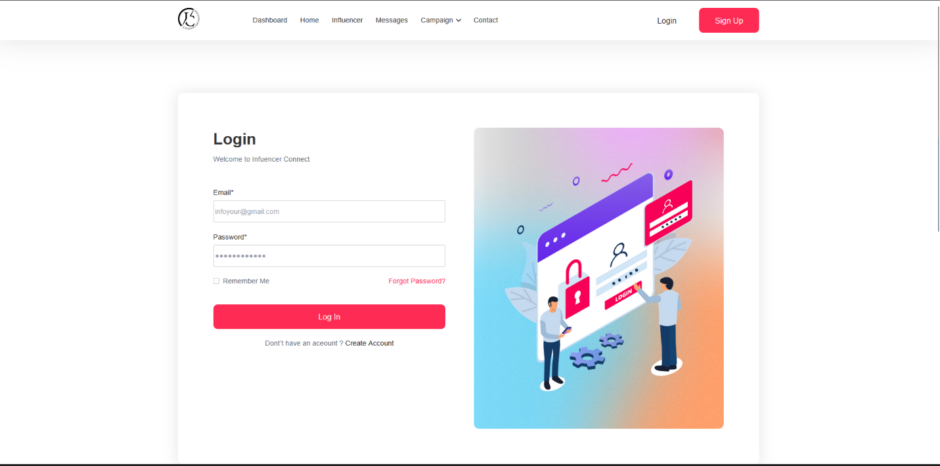

* 1. The first step of the influencer registration form, capturing basic profile info, preferred charge, and niche/category.

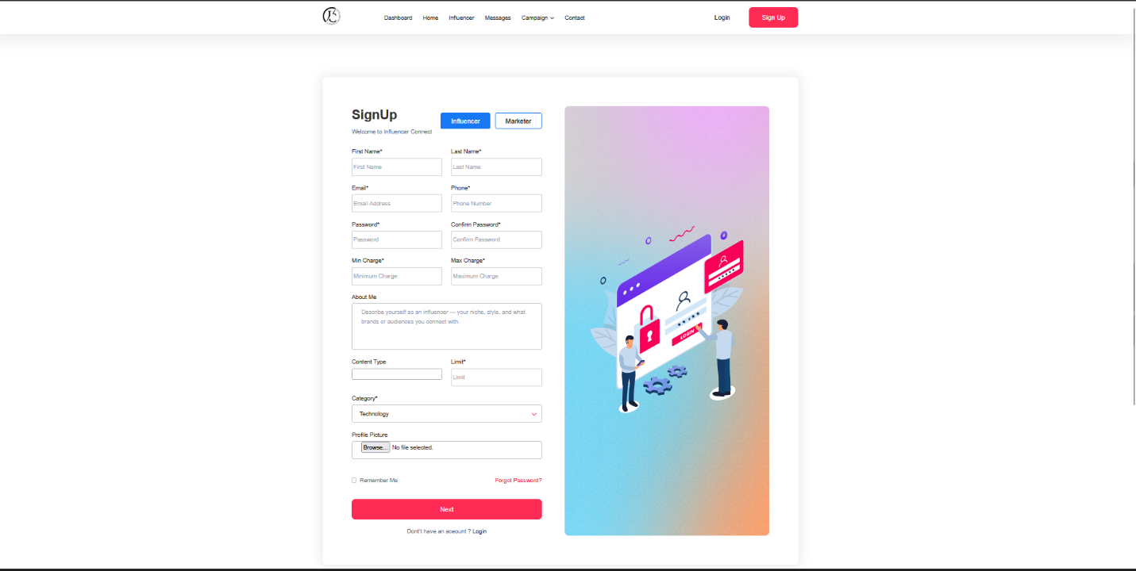

* 1. The second part of influencer registration for entering links to their Instagram, TikTok, and YouTube profiles.

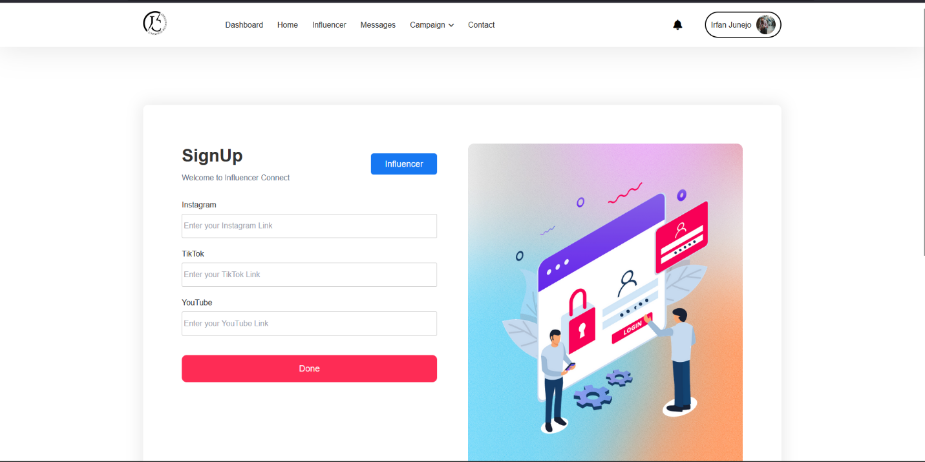

* 1. The marketing agent registration form, requiring both personal and company details for verification and platform access.

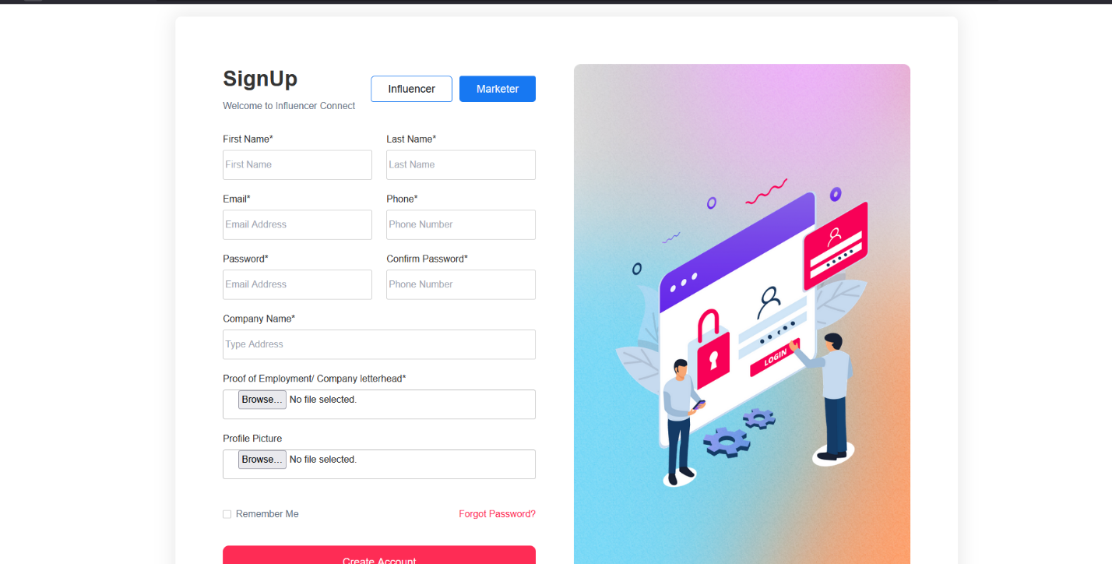

* 1. The influencer’s dashboard showcasing their active, completed, and pending campaigns, giving a quick overview of engagement status.

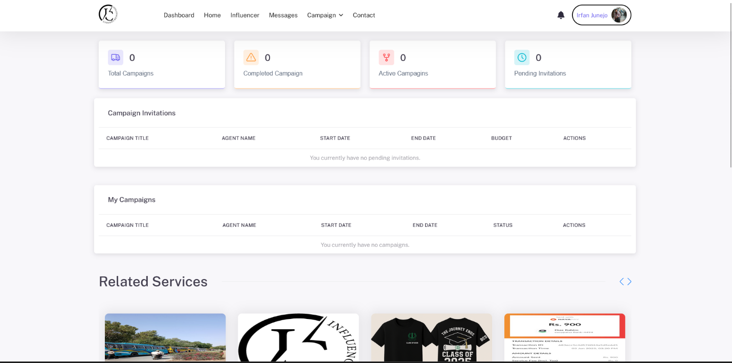

* 1. The dashboard for marketing agents, summarizing active campaigns, pending invitations, and suggested influencers.

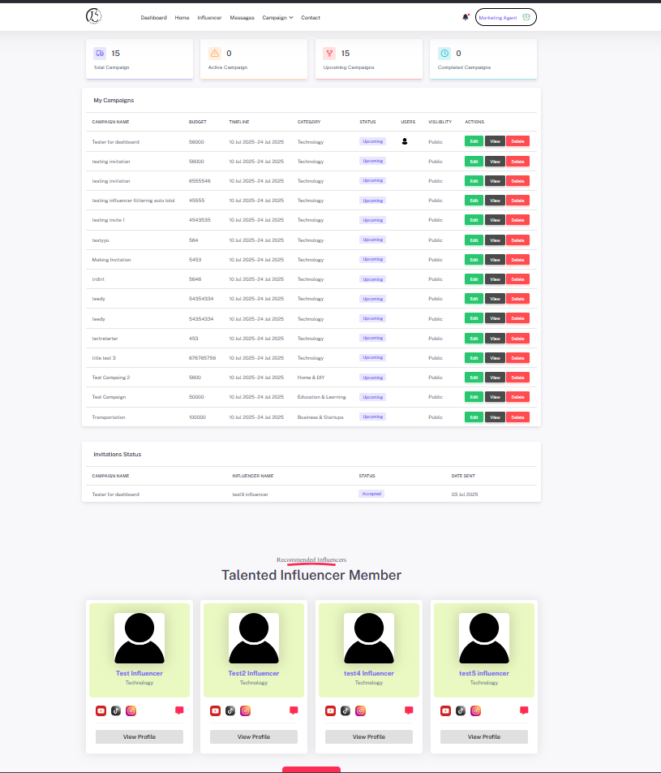

* 1. This is the first step of the campaign creation process, where marketing agents enter campaign details like title, timeline, budget, content type, and target audience.

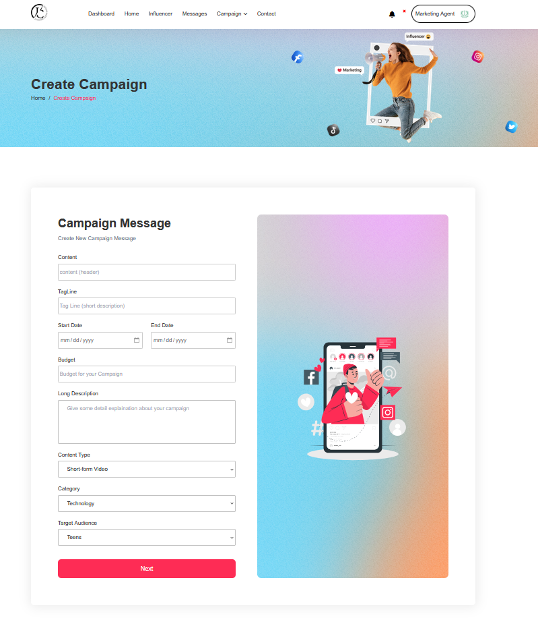

* 1. This second step of the campaign setup allows agents to upload promotional images to visually support their campaign message.

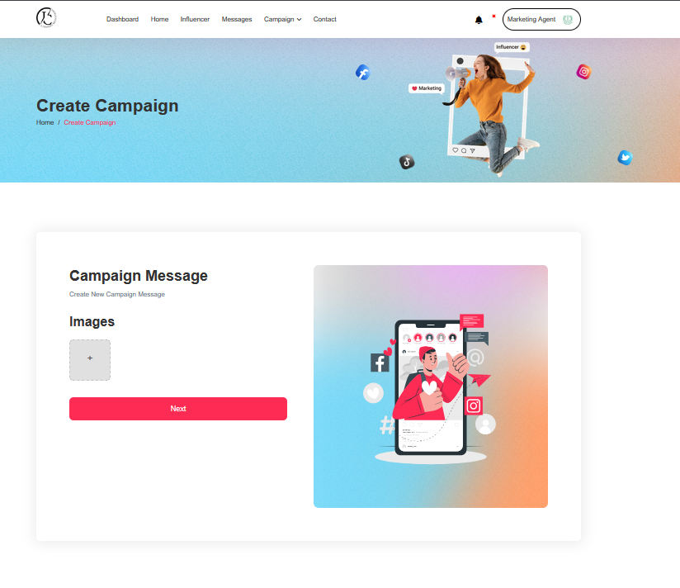

* 1. This screen lets marketing agents view influencer profiles and send direct invitations to collaborate on campaigns.

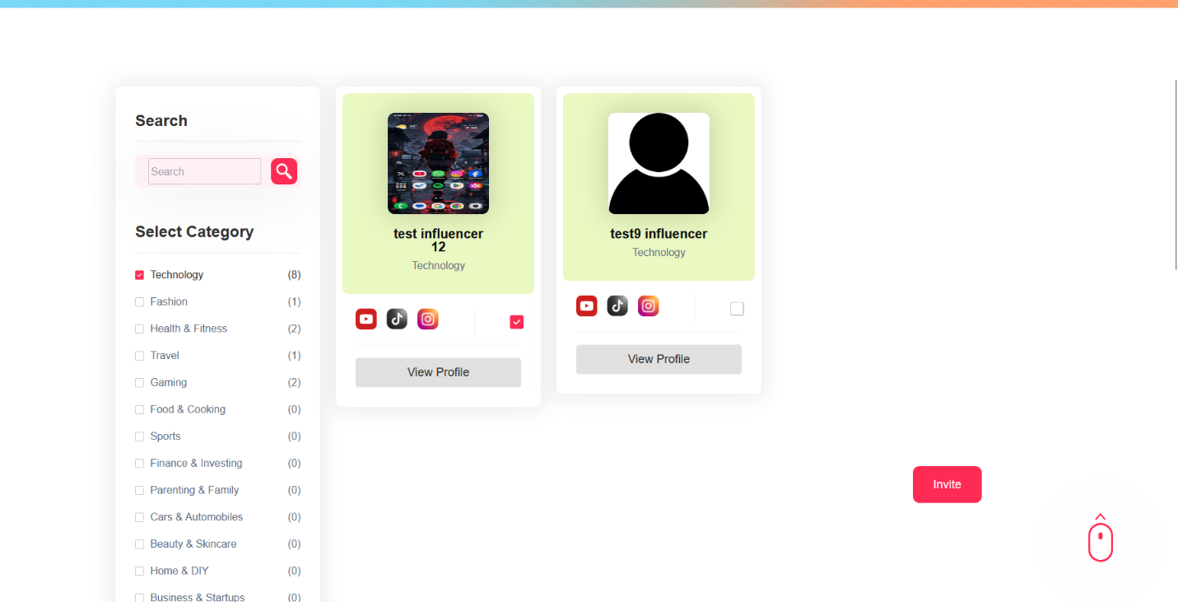

* 1. A view for influencers to browse public campaigns posted by agents, with the ability to view details and apply.

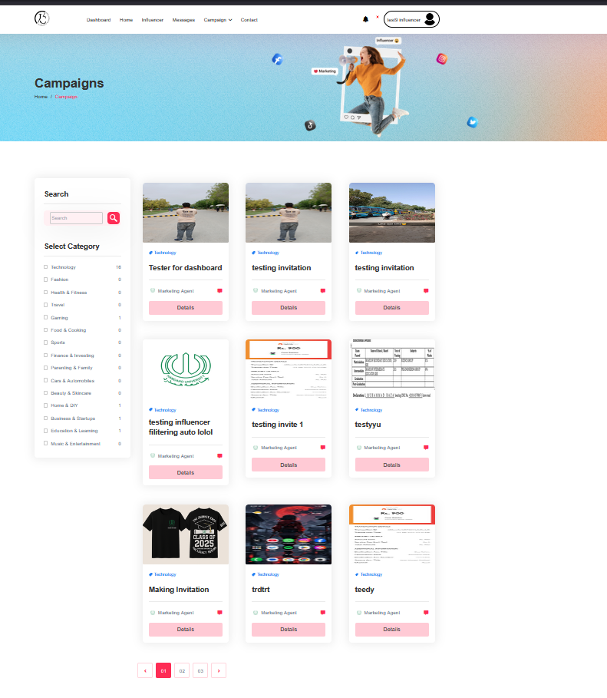

* 1. A searchable and filterable list of registered influencers, enabling marketing agents to explore and shortlist relevant profiles for their campaigns.

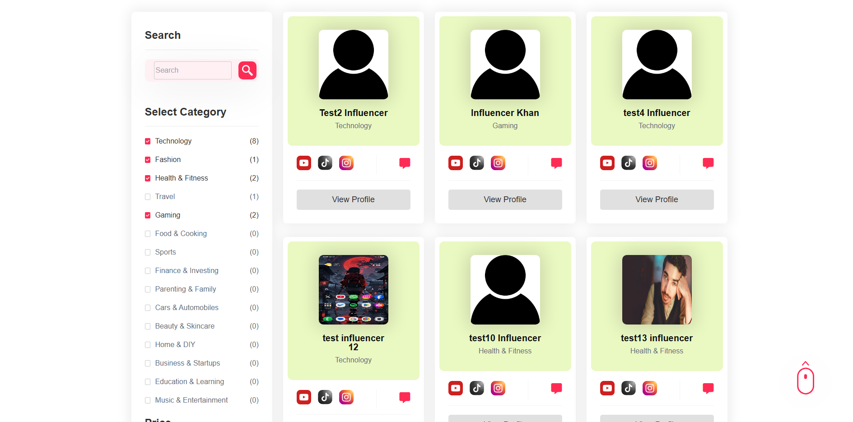

* 1. This screen shows the real-time chat interface between a marketing agent and an influencer, powered by SignalR, enabling direct communication within the platform.

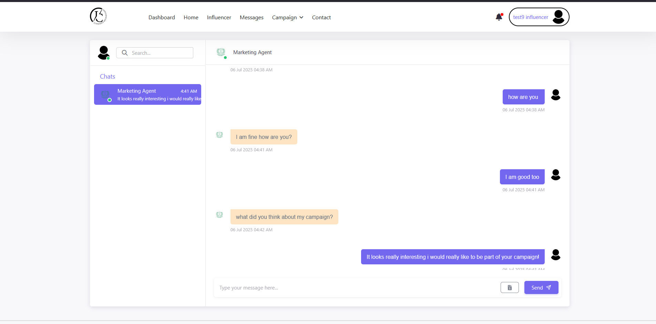

* 1. A compact invoice generation screen integrated into the chat interface, allowing agents to send payment requests to influencers upon task completion.

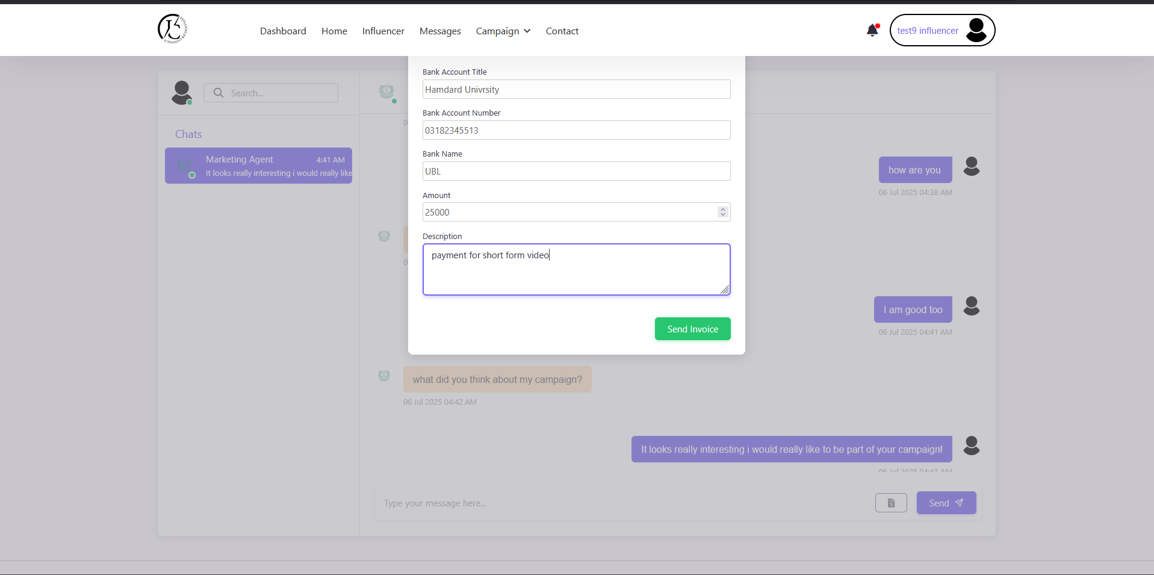

* 1. This image shows the notification dropdown where influencers get real-time alerts about messages and campaign activity.

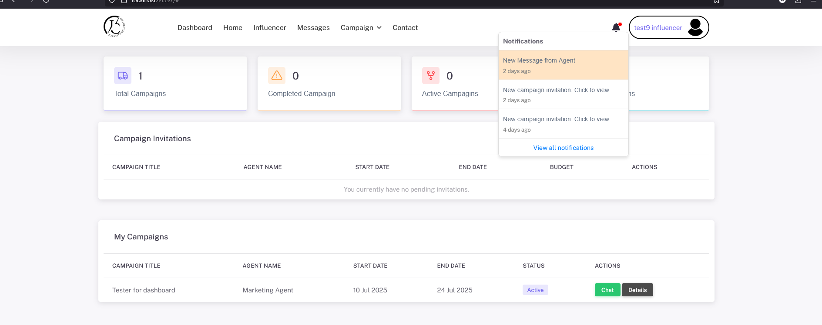

## 

## Coding Standards Document

## ****1. Introduction****

This coding standards document outlines the best practices and conventions for developing the Influencer Connect web application. The goal is to maintain high code quality, readability, consistency, and maintainability throughout the development lifecycle. These standards apply to all frontend and backend code, ensuring smooth collaboration, testing, and scalability.

## ****2. Code Formatting****

* Use **4 spaces** for indentation in C# and JavaScript/TypeScript code.
* Limit line length to **100 characters** for better readability.
* Place **opening braces {** on the same line as control statements (if, for, while, etc.).
* Maintain **one space** after commas, operators, and keywords.
* Avoid unnecessary white space and ensure consistent formatting across files.
* In Razor views (.cshtml), separate logic from layout using partial views and clear indentation.

## ****3. Naming Conventions****

* **Variables & Methods (C#):** Use camelCase for variables and PascalCase for methods.
* **Classes & Controllers:** Use PascalCase, e.g., CampaignController, UserProfile.
* **Constants:** Use UPPER_CASE_WITH_UNDERSCORES.
* **JavaScript variables/functions:** Use camelCase.
* Prefix private class fields with an underscore (_), e.g., _logger.

## ****4. Comments****

* Use **inline comments** sparingly to explain complex logic.
* **XML documentation** (///) must be used for public methods and classes.
* Use **block comments** to describe sections of code or controller logic.
* Comments should explain the why, not the what, if code is self-explanatory.

## ****5. Error Handling****

* Use try-catch blocks where exceptions are expected (especially in controller actions and services).
* Log exceptions using a centralized logging service (e.g., ILogger in ASP.NET).
* Provide **meaningful error messages** and avoid exposing sensitive data to the client.
* Return standardized error responses via JSON in APIs.

## ****6. File & Project Structure****

* Organize code into **logical folders** (e.g., Controllers, Models, Views, Services, Helpers).
* Keep related files together and follow the **MVC** pattern strictly.
* Use **descriptive filenames** (e.g., CampaignService.cs, InvoiceViewModel.cs).
* Group client-side files (e.g., JavaScript/CSS) in appropriate asset folders.

## ****7. Version Control****

* Use **Git** with clear commit messages following the convention: type(scope): message (e.g., fix(login): resolve null check error)
* Create branches for major features or fixes (e.g., feature/messaging-module)
* Merge only after code is reviewed and tested.

## ****8. Performance****

* Avoid redundant queries and optimize database access with efficient **LINQ** statements.
* Use **asynchronous programming** where necessary to prevent blocking (e.g., async/await).
* Cache reusable data when possible to minimize repeated processing.
* Minimize front-end payloads by compressing assets.

## ****9. Security****

* Role-based access control implemented using ASP.NET Identity.
* Passwords securely hashed and managed by ASP.NET Identity
* Anti-forgery tokens used in all POST forms to prevent CSRF attacks
* All database interactions use Entity Framework (ORM) to avoid SQL injection)
* Uploaded files are renamed using Guid to prevent filename conflicts and path traversal
* Input validation on both client-side and server-side
* Access to protected pages is restricted using [Authorize] attributes

## ****10. Review and Testing****

* Perform **unit testing** for business logic and **integration testing** for workflows.
* Conduct **manual UI testing** across different browsers and devices.
* Perform peer code reviews before merging to main branches.

## ****11. Conclusion****

By adhering to these coding standards, the Influencer Connect project ensures a clean, maintainable, and scalable codebase. These practices will support long-term development, simplify onboarding for future contributors, and deliver a robust, secure platform for influencer collaboration.

# A5. FLYER & POSTER DESIGN

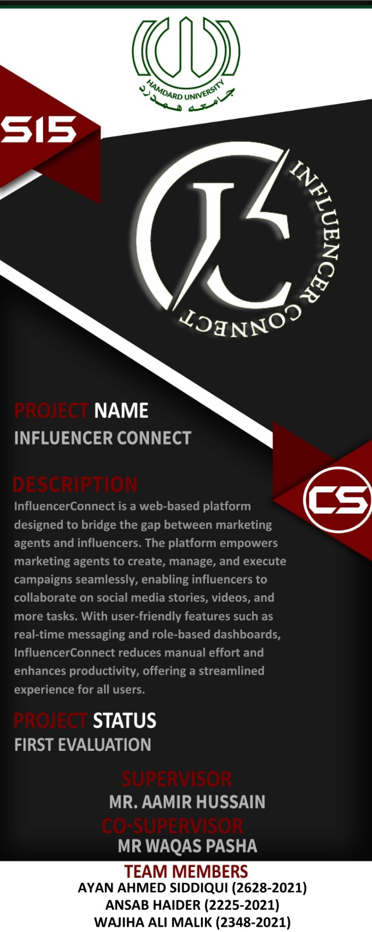

# A6. COPY OF EVALUATION COMMENTS

## COPY OF EVALUATION COMMENTS BY JURY FOR PROJECT – I END SEMESTER EVALUATION

|  |  |
| --- | --- |
|  |  |

## COPY OF EVALUATION COMMENTS BY SUPERVISOR FOR PROJECT – II END SEMESTER EVALUATION

# A7. MEETINGS’ MINUTES & Sign-Off Sheet

FYP Project 1st Meeting

Minutes of Meeting

Meeting Date: 20/02/2025

Meeting Location: Faculty Room 4

Meeting Time: 10:30 – 11:00

Project Title: Influencer Connect

Project Code: FYP-019/F24

**1- List of Participants**

|  |  |
| --- | --- |
| **Name** | **Project Role** |
| Ayan Ahmed Siddiqui | Back-end Developer |
| Ansab Haider | UI Designer |
| Wajiha Ali Malik | Front-end Developer |
|  |  |

**2- Meeting Agenda**

* FYP-1 evaluation
* Jury comments

**3- Agenda Points discussed in meeting**

* FYP-1 evaluation revived
* Jury comments of FYP-1 Evaluation discussed.

**4- Next Meeting for this project**

06-03-25 same place

# 

FYP Project 2nd Meeting

**Minutes of Meeting**

Meeting Date: 06/03/2025

Meeting Location: Faculty Room 4

Meeting Time: 9:30 – 10:00

Project Title: Influencer Connect Project Code: FYP-019/F24

# List of Participants

|  |  |
| --- | --- |
| **Name** | **Project Role** |
| Ayan Ahmed Siddiqui | Back-end Developer |
| Ansab Haider | UI Designer |
| Wajiha Ali Malik | Front-end Developer |
|  |  |

1. **Meeting Agenda**
   * Campaign Creation
   * Image handling for campaigns

# Agenda Points discussed in meeting

* + Campaign creation Back-end discussed
  + Image storage for campaigns discussed

# Next Meeting for this project

12-03-25 same place

FYP Project 3rd Meeting

Minutes of Meeting

Meeting Date: 20/03/2025

Meeting Location: Faculty Room 4

Meeting Time: 9:30 – 10:00

Project Title: Influencer Connect

Project Code: FYP-019/F24

**1- List of Participants**

|  |  |
| --- | --- |
| **Name** | **Project Role** |
| Ayan Ahmed Siddiqui | Back-end Developer |
| Ansab Haider | UI Designer |
| Wajiha Ali Malik | Front-end Developer |
|  |  |

**2- Meeting Agenda**

* User Management back end

**3- Agenda Points discussed in meeting**

* User Management (authorization, role bases access, account handling discussed.

**4- Next Meeting for this project**

03-04-25 same place

FYP Project 4th Meeting

Minutes of Meeting

Meeting Date: 09/04/2025

Meeting Location: Faculty Room 4

Meeting Time: 9:30 – 10:00

Project Title: Influencer Connect

Project Code: FYP-019/F24

**1- List of Participants**

|  |  |
| --- | --- |
| **Name** | **Project Role** |
| Ayan Ahmed Siddiqui | Back-end Developer |
| Ansab Haider | UI Designer |
| Wajiha Ali Malik | Front-end Developer |
|  |  |

**2- Meeting Agenda**

* Messaging System

**3- Agenda Points discussed in meeting**

* Messaging System discussed (SignalR)

**4- Next Meeting for this project**

17-04-25 same place

FYP Project 5th Meeting

Minutes of Meeting

Meeting Date: 17/04/2025

Meeting Location: Faculty Room 4

Meeting Time: 10:00 – 10:30

Project Title: Influencer Connect

Project Code: FYP-019/F24

**1- List of Participants**

|  |  |
| --- | --- |
| **Name** | **Project Role** |
| Ayan Ahmed Siddiqui | Back-end Developer |
| Ansab Haider | UI Designer |
| Wajiha Ali Malik | Front-end Developer |
|  |  |

**2- Meeting Agenda**

* Campaign/ Influencer recommendation

**3- Agenda Points discussed in meeting**

* Campaign/ influencer recommendation at home page discussed

**4- Next Meeting for this project**

08-05-25 same place

FYP Project 6th Meeting

**Minutes of Meeting**

Meeting Date: 08/05/2025   
Meeting Location: Faculty Room 4   
Meeting Time: 10:00 – 10:30

Project Title: Influencer Connect Project Code: FYP-019/F24

# List of Participants

|  |  |
| --- | --- |
| **Name** | **Project Role** |
| Ayan Ahmed Siddiqui | Back-end Developer |
| Ansab Haider | UI Designer |
| Wajiha Ali Malik | Front-end Developer |
|  |  |

1. **Meeting Agenda**
   * Influencer invitation
   * Notification system

# Agenda Points discussed in meeting

* + Influencer invitation system discussed
  + Notification system discussed

# Next Meeting for this project

22-06-25 same place

FYP Project 7th Meeting

Minutes of Meeting

Meeting Date: 22/05/2025

Meeting Location: Faculty Room 4

Meeting Time: 10:00 – 10:30

Project Title: Influencer Connect

Project Code: FYP-019/F24

**1- List of Participants**

|  |  |
| --- | --- |
| **Name** | **Project Role** |
| Ayan Ahmed Siddiqui | Back-end Developer |
| Ansab Haider | UI Designer |
| Wajiha Ali Malik | Front-end Developer |
|  |  |

**2- Meeting Agenda**

* Voucher generation
* Final deployment

**3- Agenda Points discussed in meeting**

* Voucher generation discussed
* Final project deployment discussed

**4- Next Meeting for this project**

Last meeting

**A9. PROJECT PROGRESS**

